

2014 Air Quality Progress Report for
East Herts Council

In fulfillment of Part IV of the
Environment Act 1995
Local Air Quality Management

April 2014

Local Authority Officer | XXXXXXX and XXXXXXX
Department | Community Safety and Health Services
Address | Wallfields, Pegs Lane, Hertford, Herts. SG13 8EQ
Telephone | 01992 531475
e-mail | Environment.health@eastherts.gov.uk
Report Reference number | EH/PR2014
Date | January 2015

Executive Summary
The Environment Act 1995 requires Local Authorities to periodically review and assess local air quality against the air quality objectives contained in the Air Quality Regulations. Local Authorities are currently undertaking the fifth round of the review and assessment. The fifth round is undertaken in two stages. Initially an Updating and Screening Assessment (USA) which is used to evaluate the Local Authorities area and to establish if any areas are likely to exceed the air quality objectives. The Second stage is to conduct, if necessary, a Detailed Assessment of the areas highlighted in the USA. Following on from this a Local Authority is required to undertake a Further Assessment. Annual Progress Reports are required for all authorities between subsequent rounds of reviews and assessments to update on changes within the district. The Progress Report allows those authorities that have declared Air Quality Management Areas to update on actions detailed in the Action Plan.

This document forms the Air Quality Progress Report for East Herts Council. In writing this report the Council has had regard to the Department for Environment Food and Rural Affairs (Defra) publication ‘Progress Report Guidance LAQM.PRG(09)’. The report provides the latest monitoring results from the air quality monitoring stations located at Cutforth Road, Sawbridgeworth, Eden’s Mount, Sawbridgeworth and the council’s network of Nitrogen Dioxide diffusion tubes.

The results from the continuous air quality monitoring stations show that the air quality objectives that Local Authorities are required to meet were achieved at both the Background and Roadside monitors. East Herts Council has a network of 42 diffusion tubes, located at 19 different sites. Diffusion tubes at 11 of these sites recorded an annual mean above the objective of 40µg/m3. These have either already been subject to detailed assessment and are awaiting the declaration of an Air Quality Management Area (AQMA), or are located within an existing AQMA. The diffusion tube located on Viaduct Road Ware recorded nitrogen dioxide equal to the Annual Mean Objective.
Table of Contents
1 Introduction 6
1.1 Description of Local Authority Area 6
1.2 Purpose of Progress Report 6
1.3 Air Quality Objectives 7
1.4 Summary of Previous Review and Assessments 9
2 New Monitoring Data 15
2.1 Summary of Monitoring Undertaken 15
2.2 Comparison of Monitoring Results with Air Quality Objectives 28
3 New Local Developments 45
3.1 Road Traffic Sources 45
3.2 Other Transport Sources 45
3.3 Industrial Sources 46
3.4 Commercial and Domestic Sources 46
3.5 New Developments with Fugitive or Uncontrolled Sources 47
4 Local / Regional Air Quality Strategy 49
5 Planning Applications 50
6 Air Quality Planning Policies 51
7 Local Transport Plans and Strategies 52
8 Climate Change Strategies 53
9 Implementation of Action Plans 55
10 Conclusions and Proposed Actions 56
10.1 Conclusions from New Monitoring Data 56
10.2 Conclusions relating to New Local Developments 56
10.3 Other Conclusions 56
10.4 Proposed Actions 56
11 References 57

List of Tables

1.1 Air Quality Objectives included in Regulations for the purpose of LAQM in England
2.1 Details of Automatic Monitoring Sites
2.2 Details of Non-Automatic Monitoring sites
2.3 Results of Automatic Monitoring for NO₂: Comparison with Annual Mean
Objective
2.4 Results of Automatic Monitoring for NO₂: Comparison with 1-Hour Mean
Objective
2.5 Results of NO₂ Diffusion tubes 2013
2.6 Results of the NO₂ Diffusion tubes (2009 to 2013)
2.7 Results of Automatic Monitoring for PM10: Comparison with Annual Mean
Objective
2.8 Results of Automatic Monitoring for PM10: Comparison with 24-hour Mean
Objective.
A.1 Short-Term to Long-Term Monitoring Data Adjustment

List of Figures

1.1 Maps of AQMA Boundaries
2.1 Map of Automatic Monitoring Sites
2.2 Maps of Non-Automatic Monitoring Sites
2.3 Trends in Annual Mean NO₂ Concentrations measured at Automatic Monitoring Sites
2.4 Trends in Annual Mean Nitrogen Dioxide Concentrations measured at
Diffusion tube Monitoring Sites
2.5 Trends in Annual Mean PM10 Concentrations

Appendices

Appendix A: QA:QC Data

1. Diffusion Tube Bias Adjustment Factors
2. Factor from Local Co-location Studies
3. Discussion of Choice of Factor to Use
4. PM Monitoring Adjustment
5. Short-term to Long-term Data adjustment
6. QA/QC of Automatic Monitoring
7. QA/QC of Diffusion Tube Monitoring

Appendix B: Graphs from Automatic Monitoring Stations

Appendix C: Detailed Breakdown of Diffusion Tube Results for 2013

Introduction

Description of Local Authority Area

East Herts covers 475 square kilometres, with a population of approximately 137,687. It is characterised by attractive rolling countryside. The small towns and villages stand in an area of great natural beauty, with winding country lanes and shallow valleys through which flow the many rivers and streams that cross the district.

East Herts is the most rural district in the County and has a great deal of natural and built heritage in the combination of villages and market towns in a predominantly rural setting. Although the district's rural character means it has an important agricultural base, the local economy is dominated by the service sector with the majority of the firms being small and medium sized enterprises.

Businesses in East Herts tend to be small or micro enterprises concentrating on the provision of services. However, there is a significant manufacturing base in the District, with an equally significant number of warehousing, distribution and real estate businesses; these are often located in small industrial estates.

The recent growth of Stansted Airport has also led to the creation of many new opportunities. This includes airport related service industries such as food preparation.

To date the main source of air pollution in East Herts is from road traffic.

Purpose of Progress Report
This report fulfils the requirements of the Local Air Quality Management (LAQM) process as set out in Part IV of the Environment Act (1995), the Air Quality Strategy for England, Scotland, Wales and Northern Ireland 2007 and the relevant Policy and Technical Guidance documents. The LAQM process places an obligation on all local authorities to regularly review and assess air quality in their areas, and to determine whether or not the air quality objectives are likely to be achieved. Where exceedences are considered likely, the local authority must then declare an Air Quality Management Area (AQMA) and prepare an Air Quality Action Plan (AQAP) setting out the measures it intends to put in place in pursuit of the objectives.

Progress Reports are required in the intervening years between the three-yearly Updating and Screening Assessment reports. Their purpose is to maintain continuity in the LAQM process.

They are not intended to be as detailed as Updating and Screening Assessment Reports, or to require as much effort. However, if the Progress Report identifies the risk of exceedence of an Air Quality Objective, the Local Authority (LA) should undertake a Detailed Assessment immediately, and not wait until the next round of Review and Assessment.

Air Quality Objectives
The air quality objectives applicable to LAQM in England are set out in the Air Quality (England) Regulations 2000 (SI 928), The Air Quality (England) (Amendment) Regulations 2002 (SI 3043), and are shown in Table 1.1. This table shows the objectives in units of microgrammes per cubic metre µg/m³ (milligrammes per cubic metre, mg/m³ for carbon monoxide) with the number of exceedences in each year that are permitted (where applicable).

Table 1.1 Air Quality Objectives included in Regulations for the purpose of LAQM in England
Pollutant | Air Quality Objective |  | Date to be achieved by
Pollutant | Concentration | Measured as | Date to be achieved by
Benzene | 16.25 µg/m³ | Running annual mean | 31.12.2003
Benzene | 5.00 µg/m³ | Annual mean | 31.12.2010
1,3-Butadiene | 2.25 µg/m³ | Running annual mean | 31.12.2003
Carbon monoxide | 10 mg/m³ | Running 8-hour mean | 31.12.2003
Lead | 0.50 µg/m³ | Annual mean | 31.12.2004
Lead | 0.25 µg/m³ | Annual mean | 31.12.2008
Nitrogen dioxide | 200 µg/m³ not to be exceeded more than 18 times a year | 1-hour mean | 31.12.2005
Nitrogen dioxide | 40 µg/m³ | Annual mean | 31.12.2005
Particulate Matter (PM₁₀) (gravimetric) | 50 µg/m³, not to be exceeded more than 35 times a year | 24-hour mean | 31.12.2004
Particulate Matter (PM₁₀) (gravimetric) | 40 µg/m³ | Annual mean | 31.12.2004
Sulphur dioxide | 350 µg/m³, not to be exceeded more than 24 times a year | 1-hour mean | 31.12.2004
Sulphur dioxide | 125 µg/m³, not to be exceeded more than 3 times a year | 24-hour mean | 31.12.2004
Sulphur dioxide | 266 µg/m³, not to be exceeded more than 35 times a year | 15-minute mean | 31.12.2005

Summary of Previous Review and Assessments

The Council completed the first round of the review and assessment process and declared an Air Quality Management Area (AQMA) for Nitrogen Dioxide (NO₂) and (PM10). This included a number of residential properties adjacent to the A1184 Cambridge Road in Sawbridgeworth from the junction with Crest North to the junction with Station Road/West Street on both sides of the road, and from the same junction north to 98 Cambridge Road on the east side of the road only.

The air quality monitoring site known as East Herts Roadside (located at Cutforth Road) was installed in 2001 to monitor PM10 and NO₂ levels in this area. As a result of this monitoring the Air Quality Management Area was revoked in September 2004.

Two temporary monitoring sites were installed during 2004 as a result of the findings and recommendations detailed in the Updating Screening Assessment - Netcen (2003), both of these continuously monitored for NO₂. The first, on Viaduct Road in Ware, was closed at the end of the year as results showed that the objective levels would be achieved in this location. The second, on London Road in Bishop’s Stortford continued to operate for approximately 11.5 years.

In August 2005 East Herts District Council submitted an Air Quality Progress Report to Defra. This report included the monitoring undertaken from the temporary continuous monitors in addition to the information submitted in the detailed investigation mentioned above (January 2005). The aim of this investigation was to establish the levels of Nitrogen Dioxide in Viaduct Road, Ware and London Road, Bishop's Stortford to identify if there was a legal requirement to declare Air Quality Management Areas in Ware (Viaduct Road) and Bishop Stortford (Hockerill Street/London Road junction). As a result of this report East Herts Council has declared an AQMA in Bishops Stortford.

In April 2006 East Herts District Council reviewed the air quality across the district to establish if there were any areas previously unidentified that would need further investigation. This report considers the conclusions drawn in previous reporting; any new source of pollution since the last round of Review and Assessment and establishes the risk of exceedences of the Air Quality Objectives in areas of public exposure. The report concluded there was no need for any further detailed assessments.

The further assessment submitted in April 2008 confirmed that East Herts District Council was right in declaring the crossroads known as Hockerill junction in Bishop Stortford as an AQMA. A source apportionment study concluded that HGVs were mainly responsible for the exceedence in NO₂ at the junction. Proposals to reduce the number of HGVs and other vehicles at the junction are outlined in Hertfordshire County Council’s County & District Air Quality Action Plan.

In April 2008, East Herts District Council submitted a Progress Report; the report concluded that the Air Quality Management Area should remain at the Hockerill Junction. The diffusion tube at West Street, Hertford exceeded the objective level. It was therefore recommended that diffusion tubes should be collocated in triplicate at this location. The information gathered should then be reviewed and reported in the Updating Screening Assessment in April 2009, and if necessary proceed to a detailed assessment of the area in 2011.

The 2009 Updating and Screening Assessment required detailed assessments to be carried out at Gascoyne Way, Hertford and Viaduct Road Ware. These assessments concluded that an AQMA needed to be declared at Gascoyne Way (see figure 1.1). However it was noted that the sole diffusion tube on Viaduct Road was located next to a heating vent and therefore the results and conclusions were unreliable. East Herts Council decide to undertake further monitoring at alternative locations to ascertain whether or not the vent was artificially elevating the results at this monitoring point.

The 2010 progress report concluded that a detailed assessment was required in the area of Ware Road and Old Cross, Hertford. It was decided to carry out this work as part of the further assessment on the already declared AQMA at Gascoyne Way. It was also considered necessary to install additional diffusion tubes in the vicinity of EH14 – London Road, Sawbridgeworth. Further monitoring is required to try to determine why there is such a discrepancy between the diffusion tube data and the roadside continuous monitoring in the area.

In April 2011 East Herts Council commissioned a consultancy know as AQC to carry out a Further Assessment on the Gascoyne Way, Hertford AQMA. This assessment considered the need to expand the AQMA to include the following diffusion tubes located at Old Cross, Hertford and Ware Road, Hertford which failed the annual objective in 2009.

The 2010 results from the continuous air quality monitoring stations showed that the air quality objectives were achieved. Diffusion tube data for this year showed that the air quality objectives were unlikely to be met at 10 locations (27 tubes) in the district, most of which were already subject to detailed assessment or were located within an Air Quality Management Area (AQMA) As a result of the 2011 progress report a detailed assessment was undertaken on London Road, Sawbridgeworth.

The 2011 annual mean concentrations for nitrogen dioxide and PM10s at both continuous monitoring sites were below the 40 µg/m3 objective. The hourly mean objectives for both pollutants were also met. The annual mean objective of 40µg/m3 was exceeded at 11 nitrogen dioxide diffusion tube locations, 6 of these are already in an AQMA and 2 are in a proposed extension. A distance from road calculation concluded that the concentration of NO₂ at the nearest relevant receptor at 2 locations was below the 40 µg/m3 threshold. A detailed assessment was undertaken in respect of London Road, Sawbridgeworth, but not to the same extent as concluded in the Progress Report 2011.

A Detailed Assessment was undertaken for Sawbridgeworth to determine the extent of the area affected by nitrogen dioxide in excess of the objective level. This identified parts of London road, Cambridge road, West road and Station Road as being exposed to elevated levels of nitrogen dioxide. The assessment identified this area as having an annual mean nitrogen dioxide as in excess of 36µg/m³. This level was considered appropriate as a precautionary measure. The Council then proceeded to consultation prior to the formal declaration of an Air Quality Management Area here.
The results from the 2013 Progress Report show that the background continuous air quality monitoring station met the required objectives for both nitrogen dioxide and PM10s. Whilst meeting the PM10 objective, the Roadside monitoring station failed the annual objective for Nitrogen Dioxide. Nitrogen dioxide diffusion tubes at 8 of the 16 locations exceeded the annual mean objective of 40µg/m3. Most of these have already been subject to detailed assessment or are located within an Air Quality Management Area (AQMA). The remaining diffusion tubes are located at London Road, Sawbridgeworth where AQC have undertaken a detailed assessment on behalf of East Herts Council. A further location at Viaduct road in Ware recorded an annual mean of 40µg/m3. It was considered to be appropriate to keep a watching brief on this location as it has tended to fluctuate just below the objective level and many other tubes measured an increase in concentrations in 2013. As this tube recorded 40µg/m3 at 1.83m from the road, the nearest receptor at 3.1m from the road would not be exposed to nitrogen dioxide levels above the objective level.

Figure 1.1 Maps of AQMA Boundaries

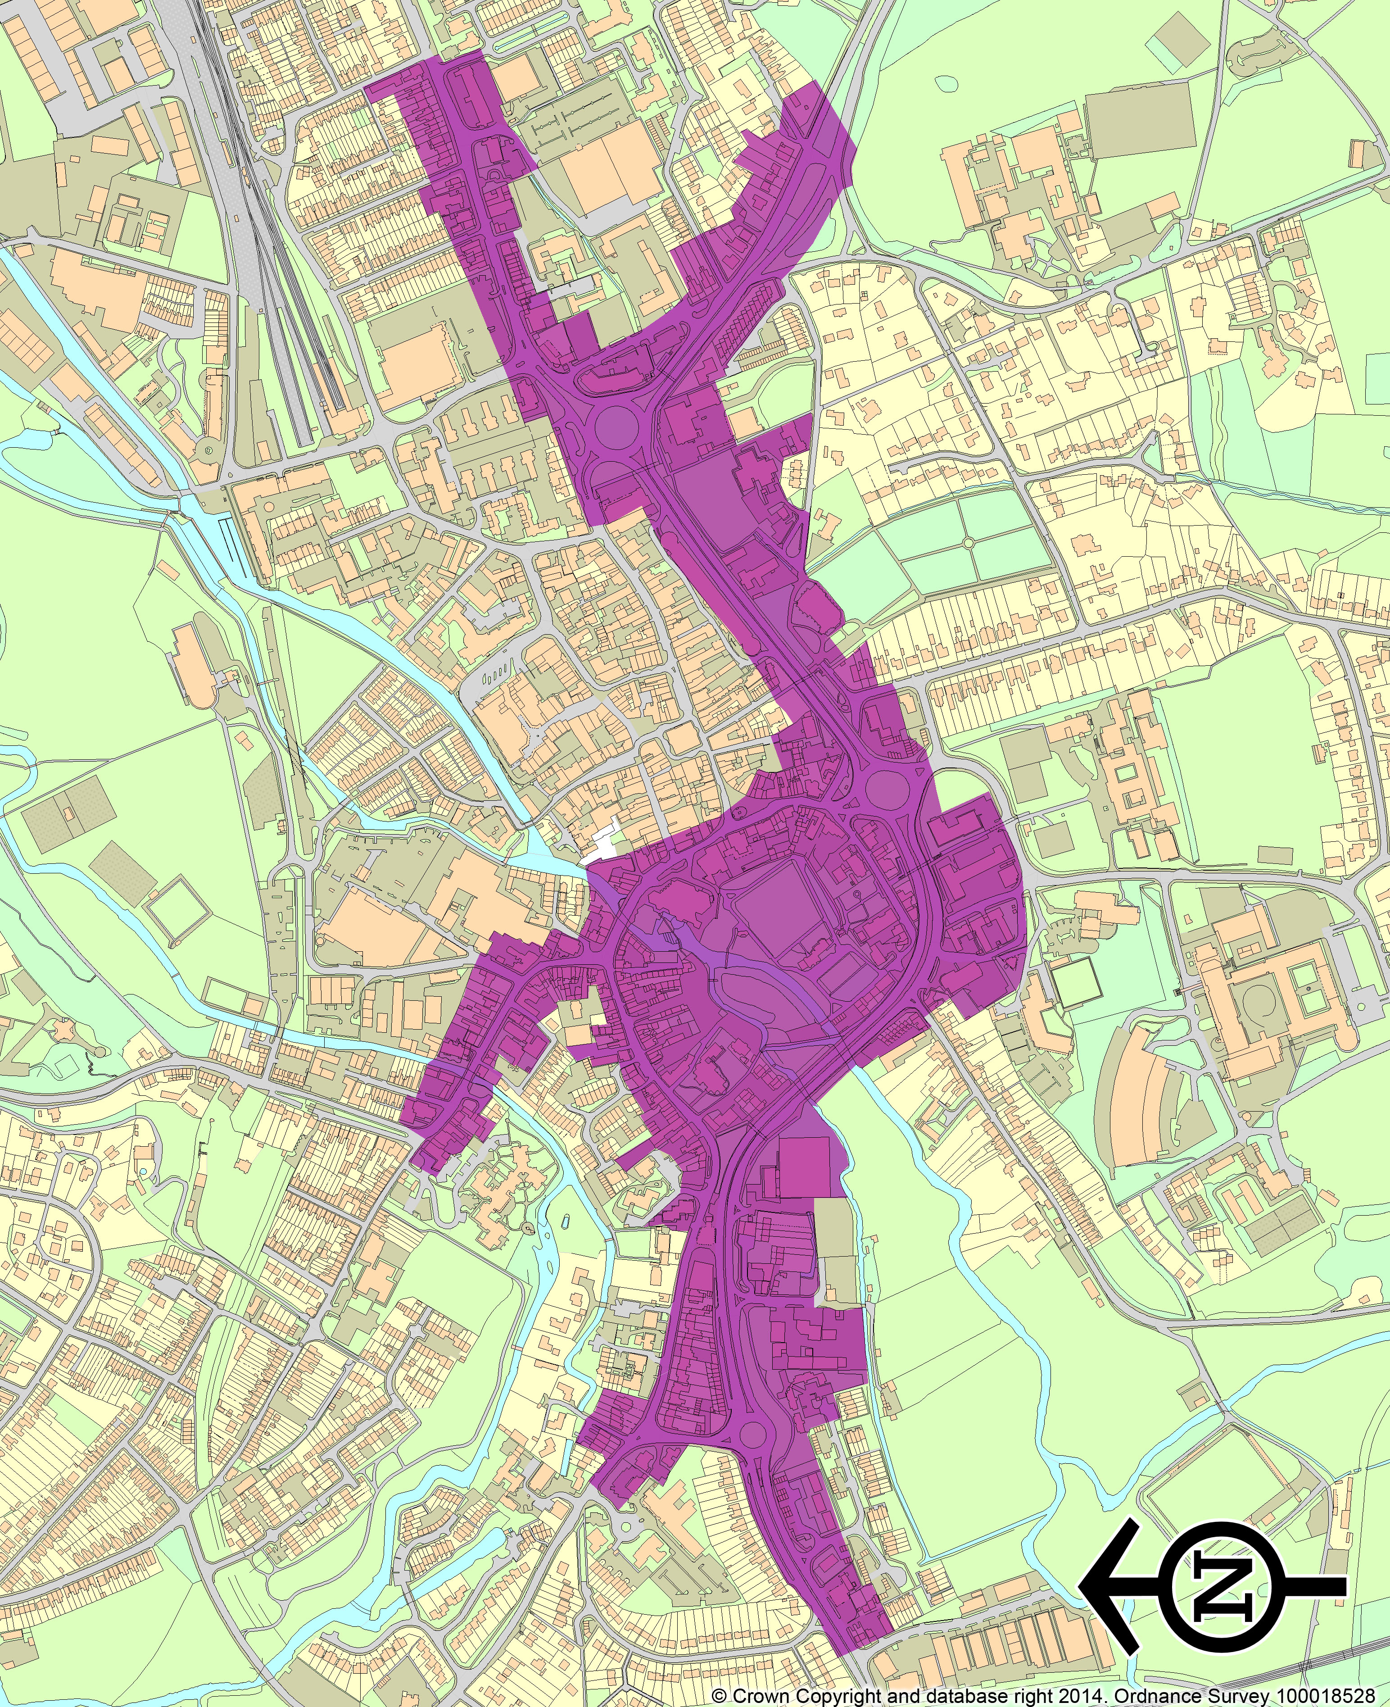
Hertford AQMA, Gascoyne Way
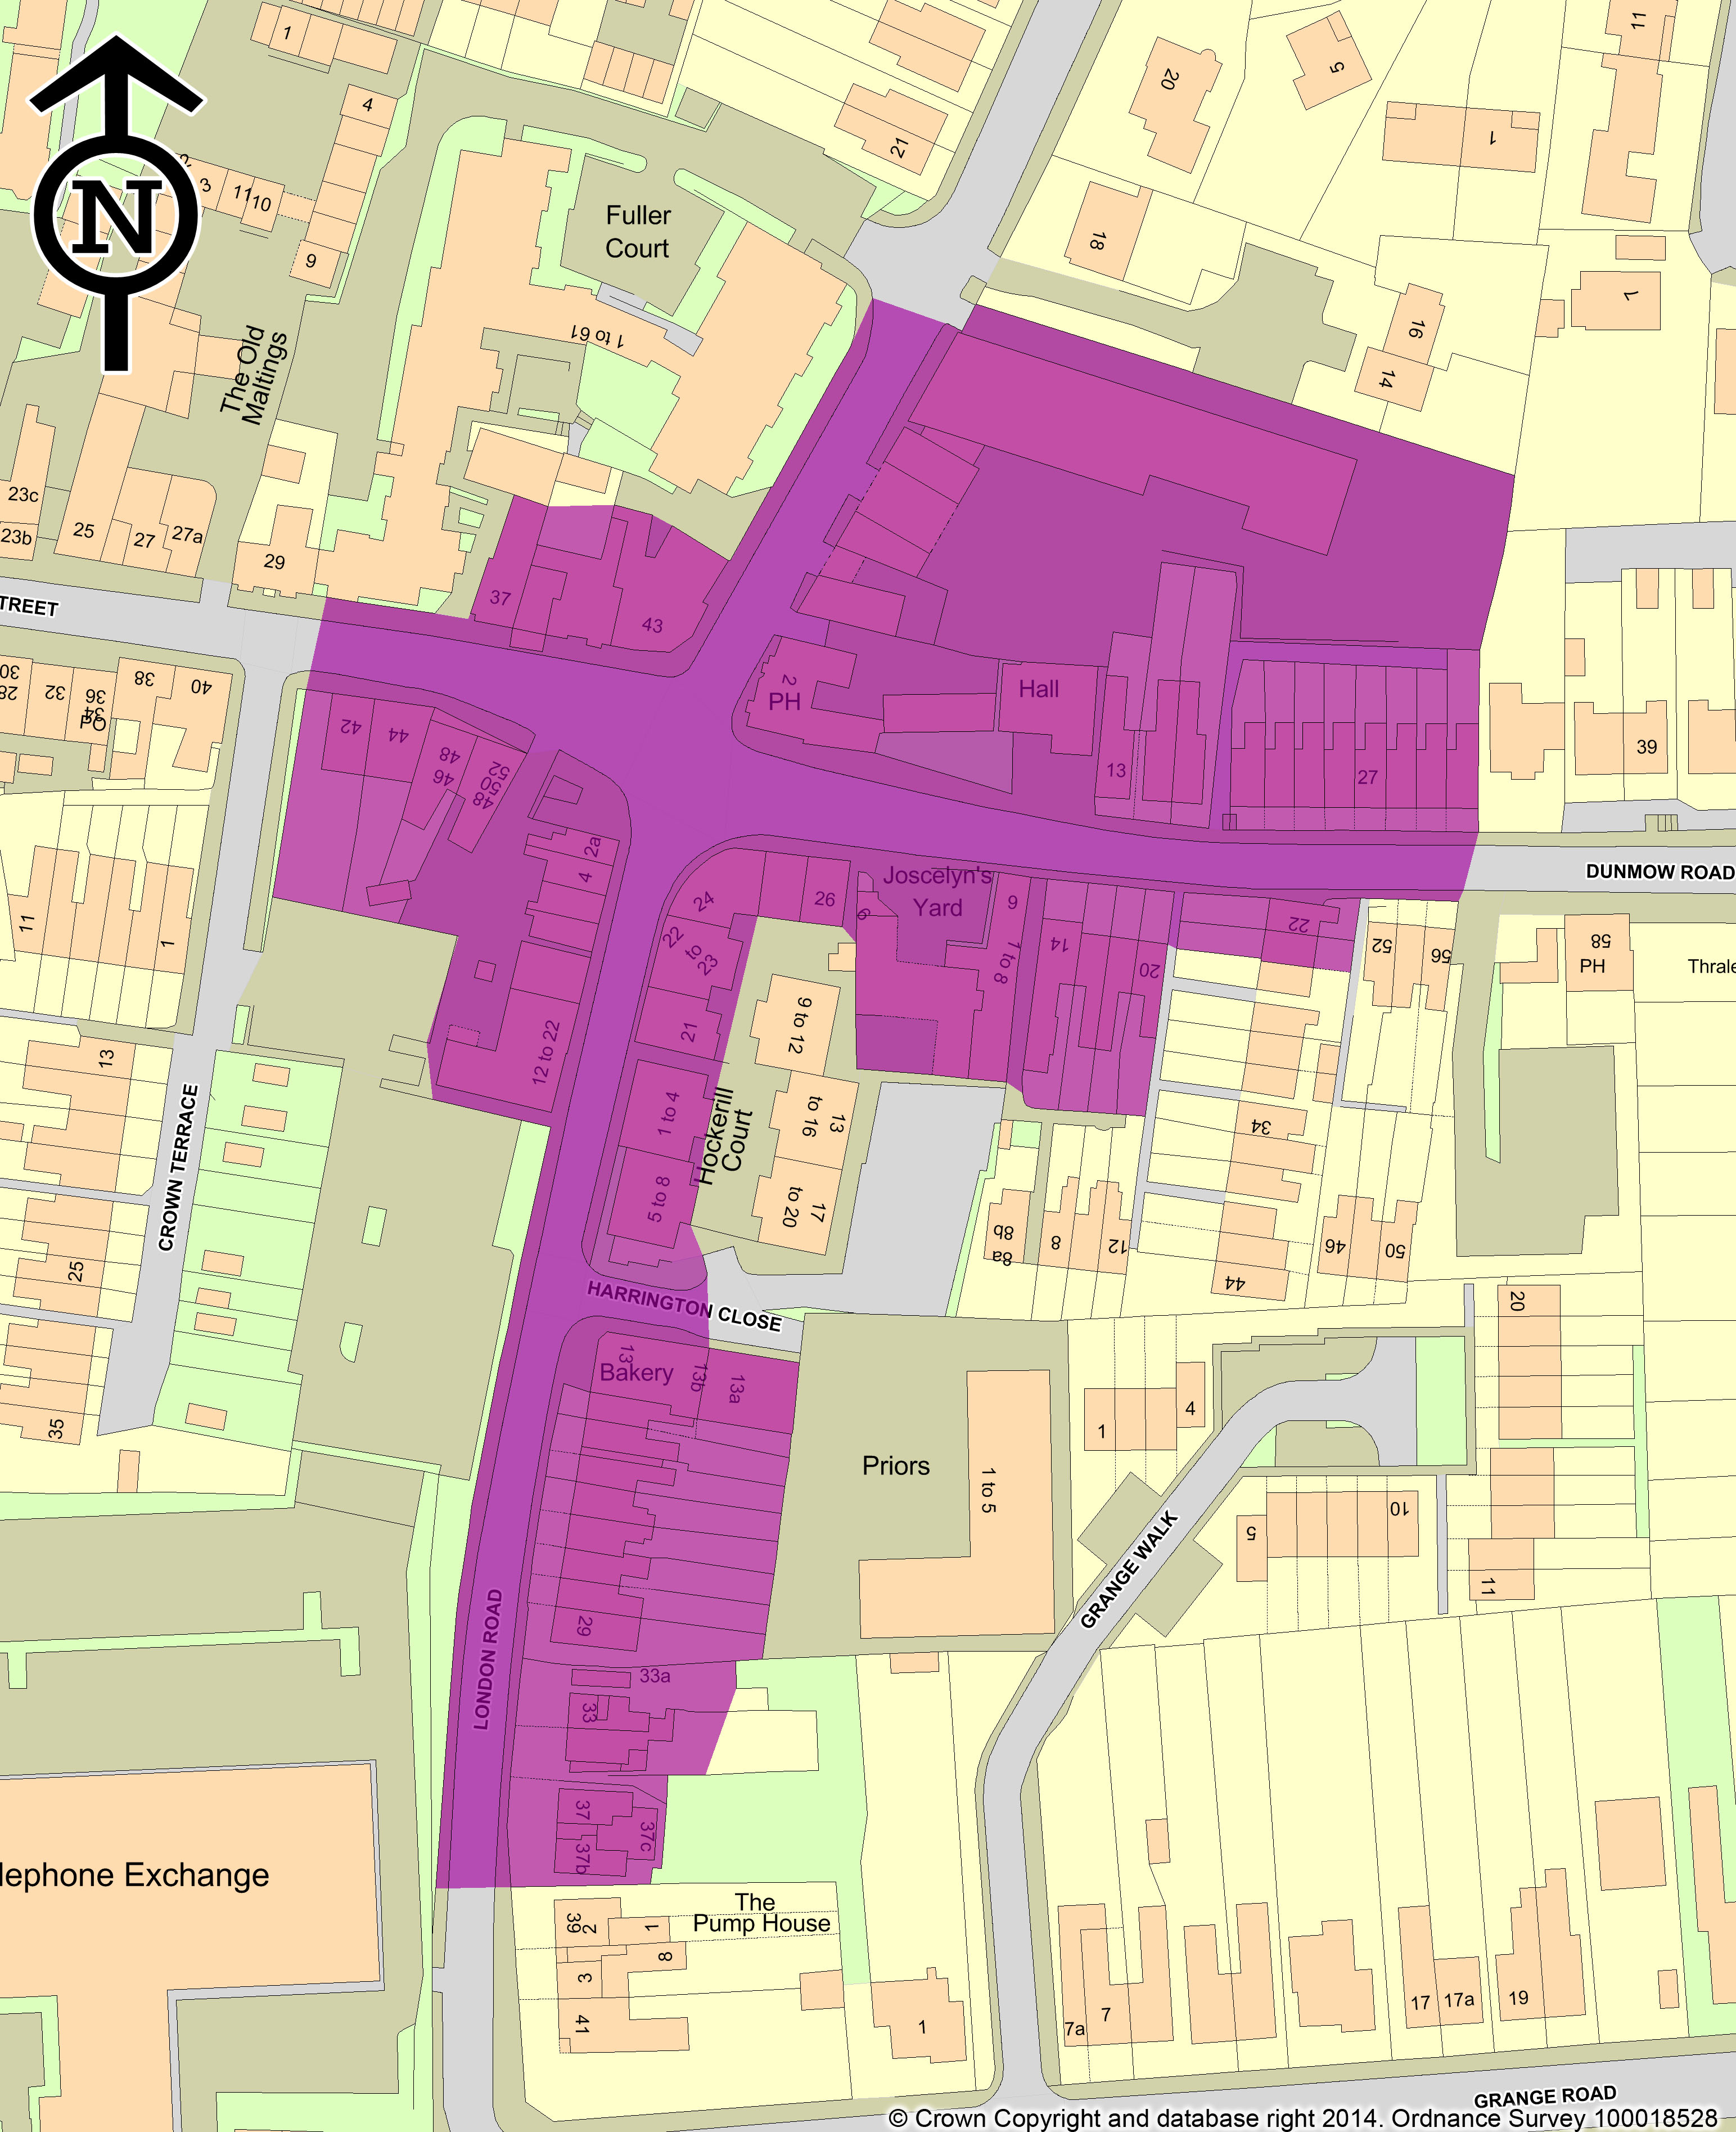
Bishop’s Stortford AQMA, Hockerill Junction

New Monitoring Data

Summary of Monitoring Undertaken

Automatic Monitoring Sites

East Herts Council has two air quality monitoring sites in its district as detailed in table 2.1 below.

Quality Assurance / Quality Control of Automatic Monitoring sites

The sites are calibrated by the Local Authority (Local Site Operator) on a fortnightly basis. The analysers were covered by a service and maintenance contract with SupportingU.

The data from the Air Quality Management Stations was ratified by a company known as AQDM according to the Automatic Urban Rural Network (AURN) standard. The data undergoes ‘daily sensibility’ checks 365 days per year. It is then further ratified on a monthly basis, taking Local Site Operator and Engineer visits into account. It is reviewed again as an annual dataset at the end of the year. The data is then compared to data collected from other local network monitoring sites.

Correction of TEOM data

East Herts Council monitors PM₁₀ at 2 locations using a Teom monitor. The volatile correction model (VCM) has been used to correct the data. The model allows the correction of TEOM measurements for the loss of volatile components of particulate matter that occur due to the high sampling temperatures employed by this instrument. The resulting corrected measurements have been demonstrated as equal to the gravimetric reference equivalent. AQDM has applied the correction model to all PM10 data listed in this document (see appendix A4).

Figure 2.1 Map of Automatic Monitoring Sites

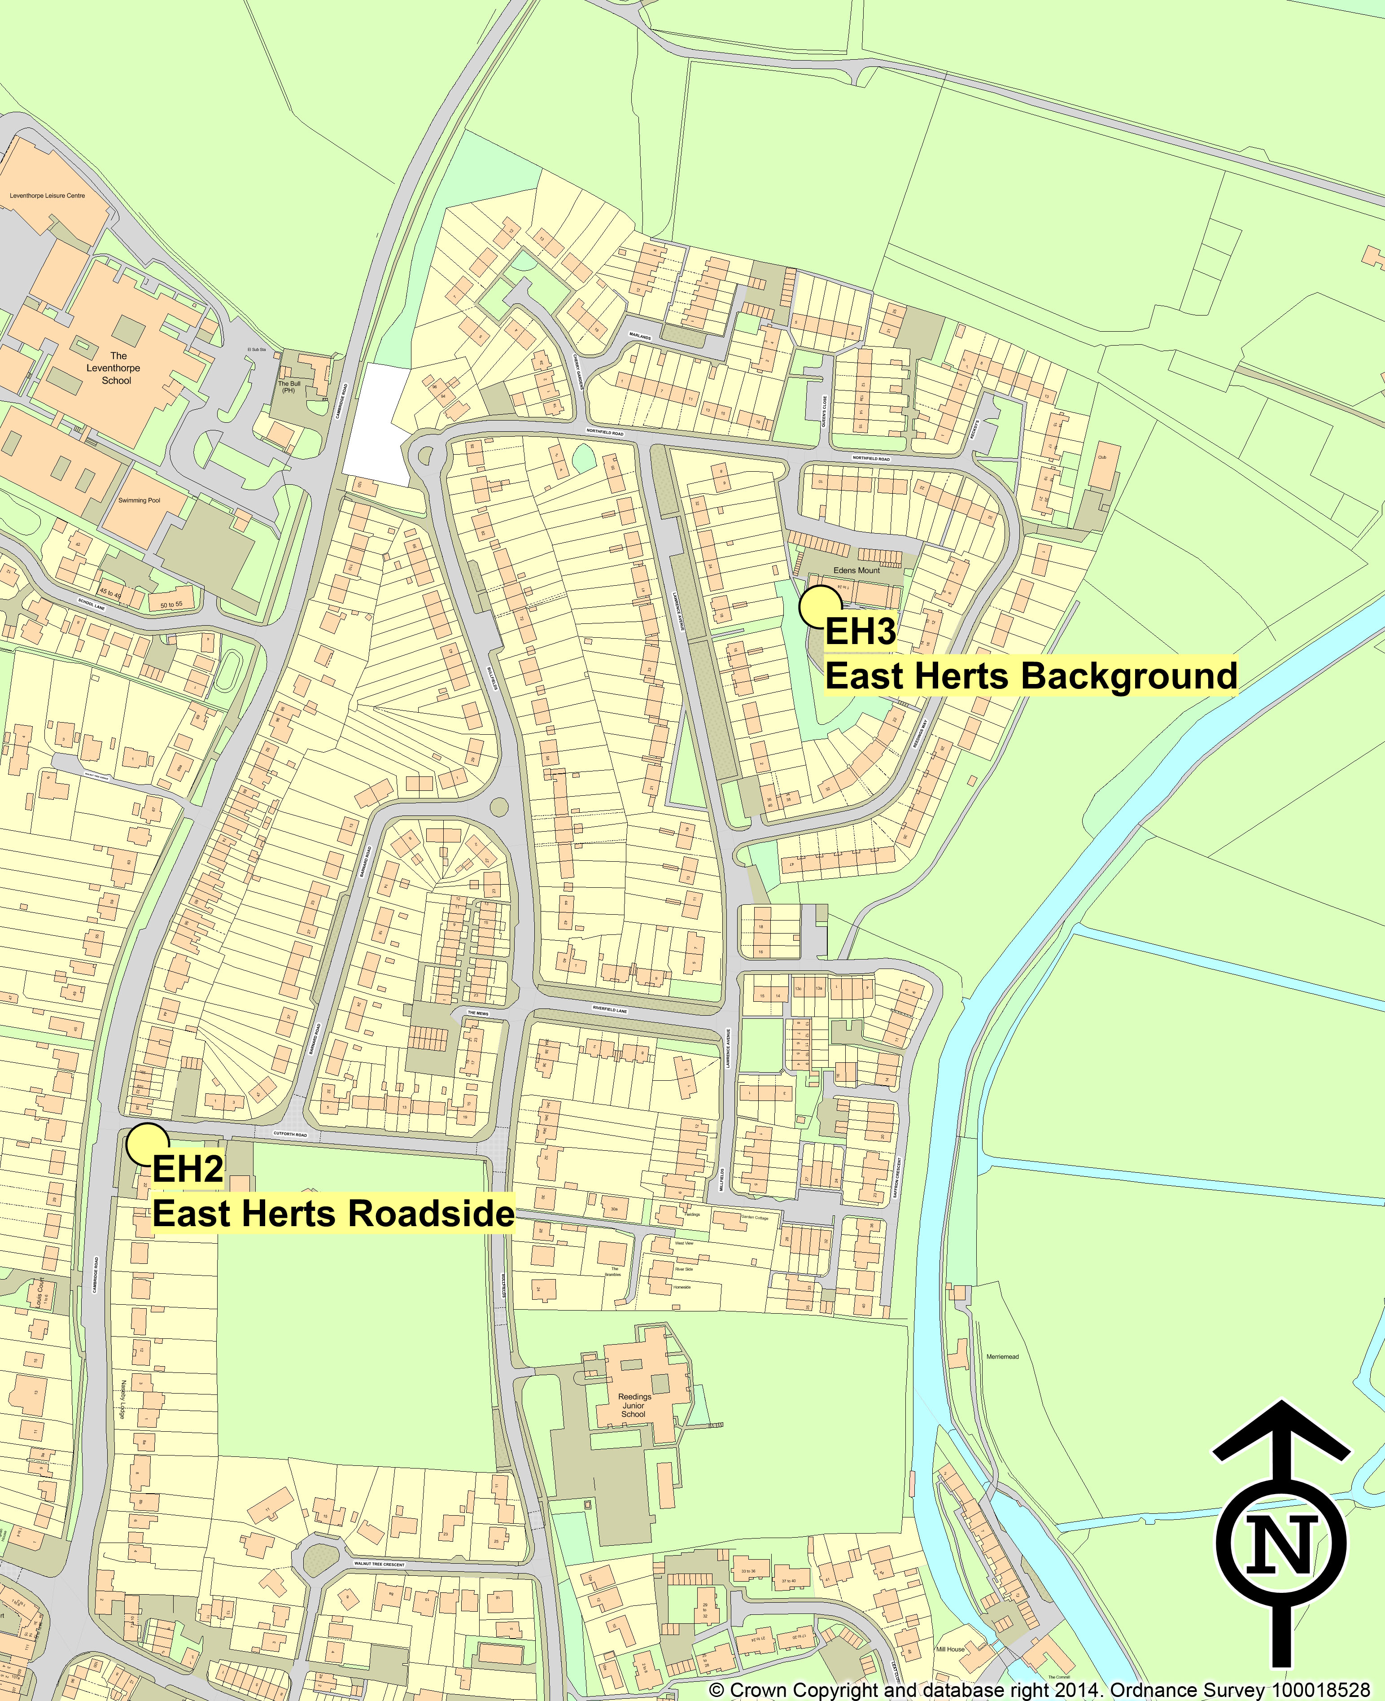

Table 2.1 Details of Automatic Monitoring Sites
Site ID | Site Name | Site Type | X OS Grid Reference | Y OS Grid Reference | Inlet Height (m) | Pollutants Monitored | In AQMA? | Monitoring Technique | Relevant Exposure? (Y/N with distance (m) from monitoring site to relevant exposure) | Distance to Kerb of Nearest Road (m) (N/A if not applicable) | Does this Location Represent Worst-Case Exposure?
EH2 | East Herts Roadside | Roadside | 548222 | 215395 | 2.0 | NO₂  PM₁₀ | N | Chemilumin-escence Analysers  TEOM | N | 2m | N
EH3 | East Herts Background | Urban Background | 548550 | 215646 | 3.0 | NO₂  PM₁₀ | N | Chemilumin-  escence Analysers  TEOM | N | N/A | N
EH4 | Anstey | Rural | 540449 | 232777 | 2.0 | Ozone | N | Chemilumin-escence Analyser | N | N/A | N

Non-Automatic Monitoring Sites

East Herts Council currently has a network of 42 diffusion tubes, a number of which are collocated in duplicate or triplicate as mentioned in Table 2.2. In April 2009 East Herts changed their diffusion tube supplier from Lambeth Scientific Services (using the 50% TEA in acetone method) to Gradko, using the 20% TEA in Water to improve on the precision of the results.

In 2013 Gradko scored a 100% in the all three rounds of the WASP scheme. Gradko were also determined good in the results of the laboratory precision scheme.

Collocation Study and Bias Adjustment

East Herts undertook a collocation study, in accordance with the reference method at the roadside continuous monitoring site located at Cutforth road, Sawbridgeworth. The Local Bias Adjustment factor was calculated as 0.84 (see Appendix A2). The National Bias Adjustment Factor was calculated as 0.95 (see Appendix A1). As the co-location study at Cutforth Road had not been in operation for the whole of 2013 it was decided to take the precautionary approach and use the National Bias Adjustment factor.
Figure 2.2 Maps of Non-Automatic Monitoring Sites

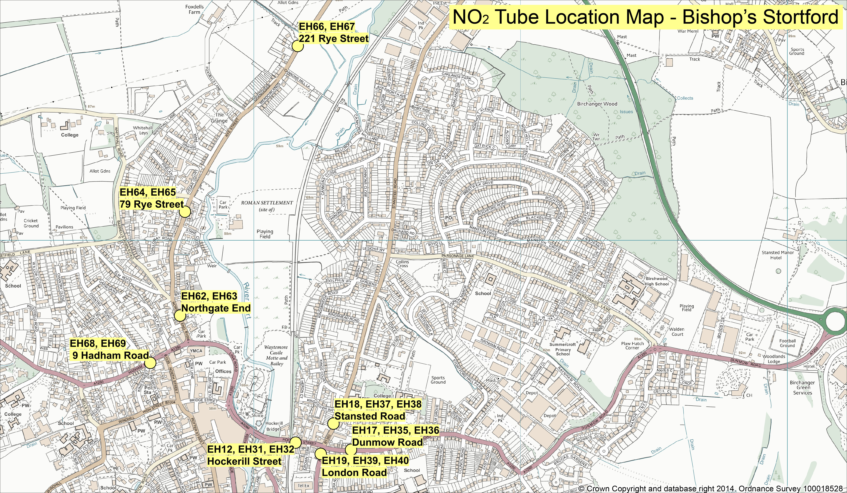

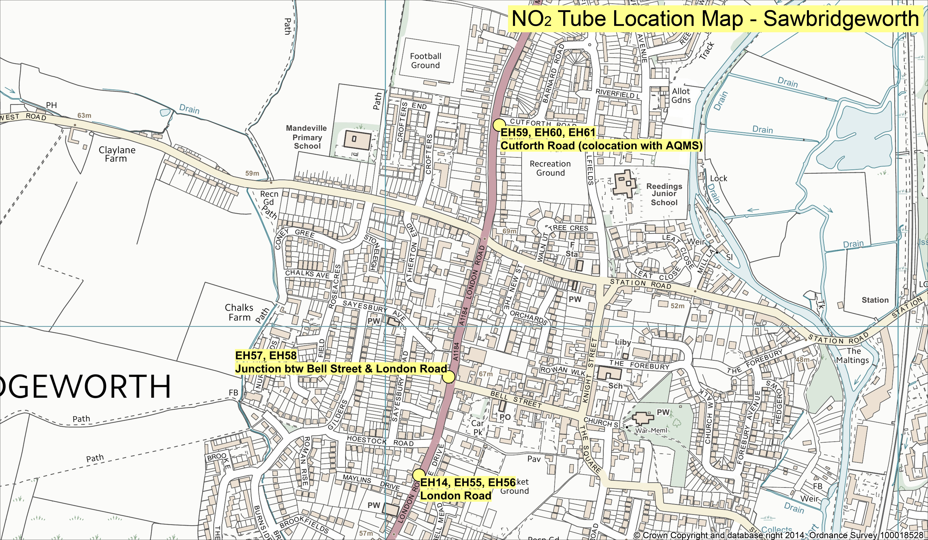

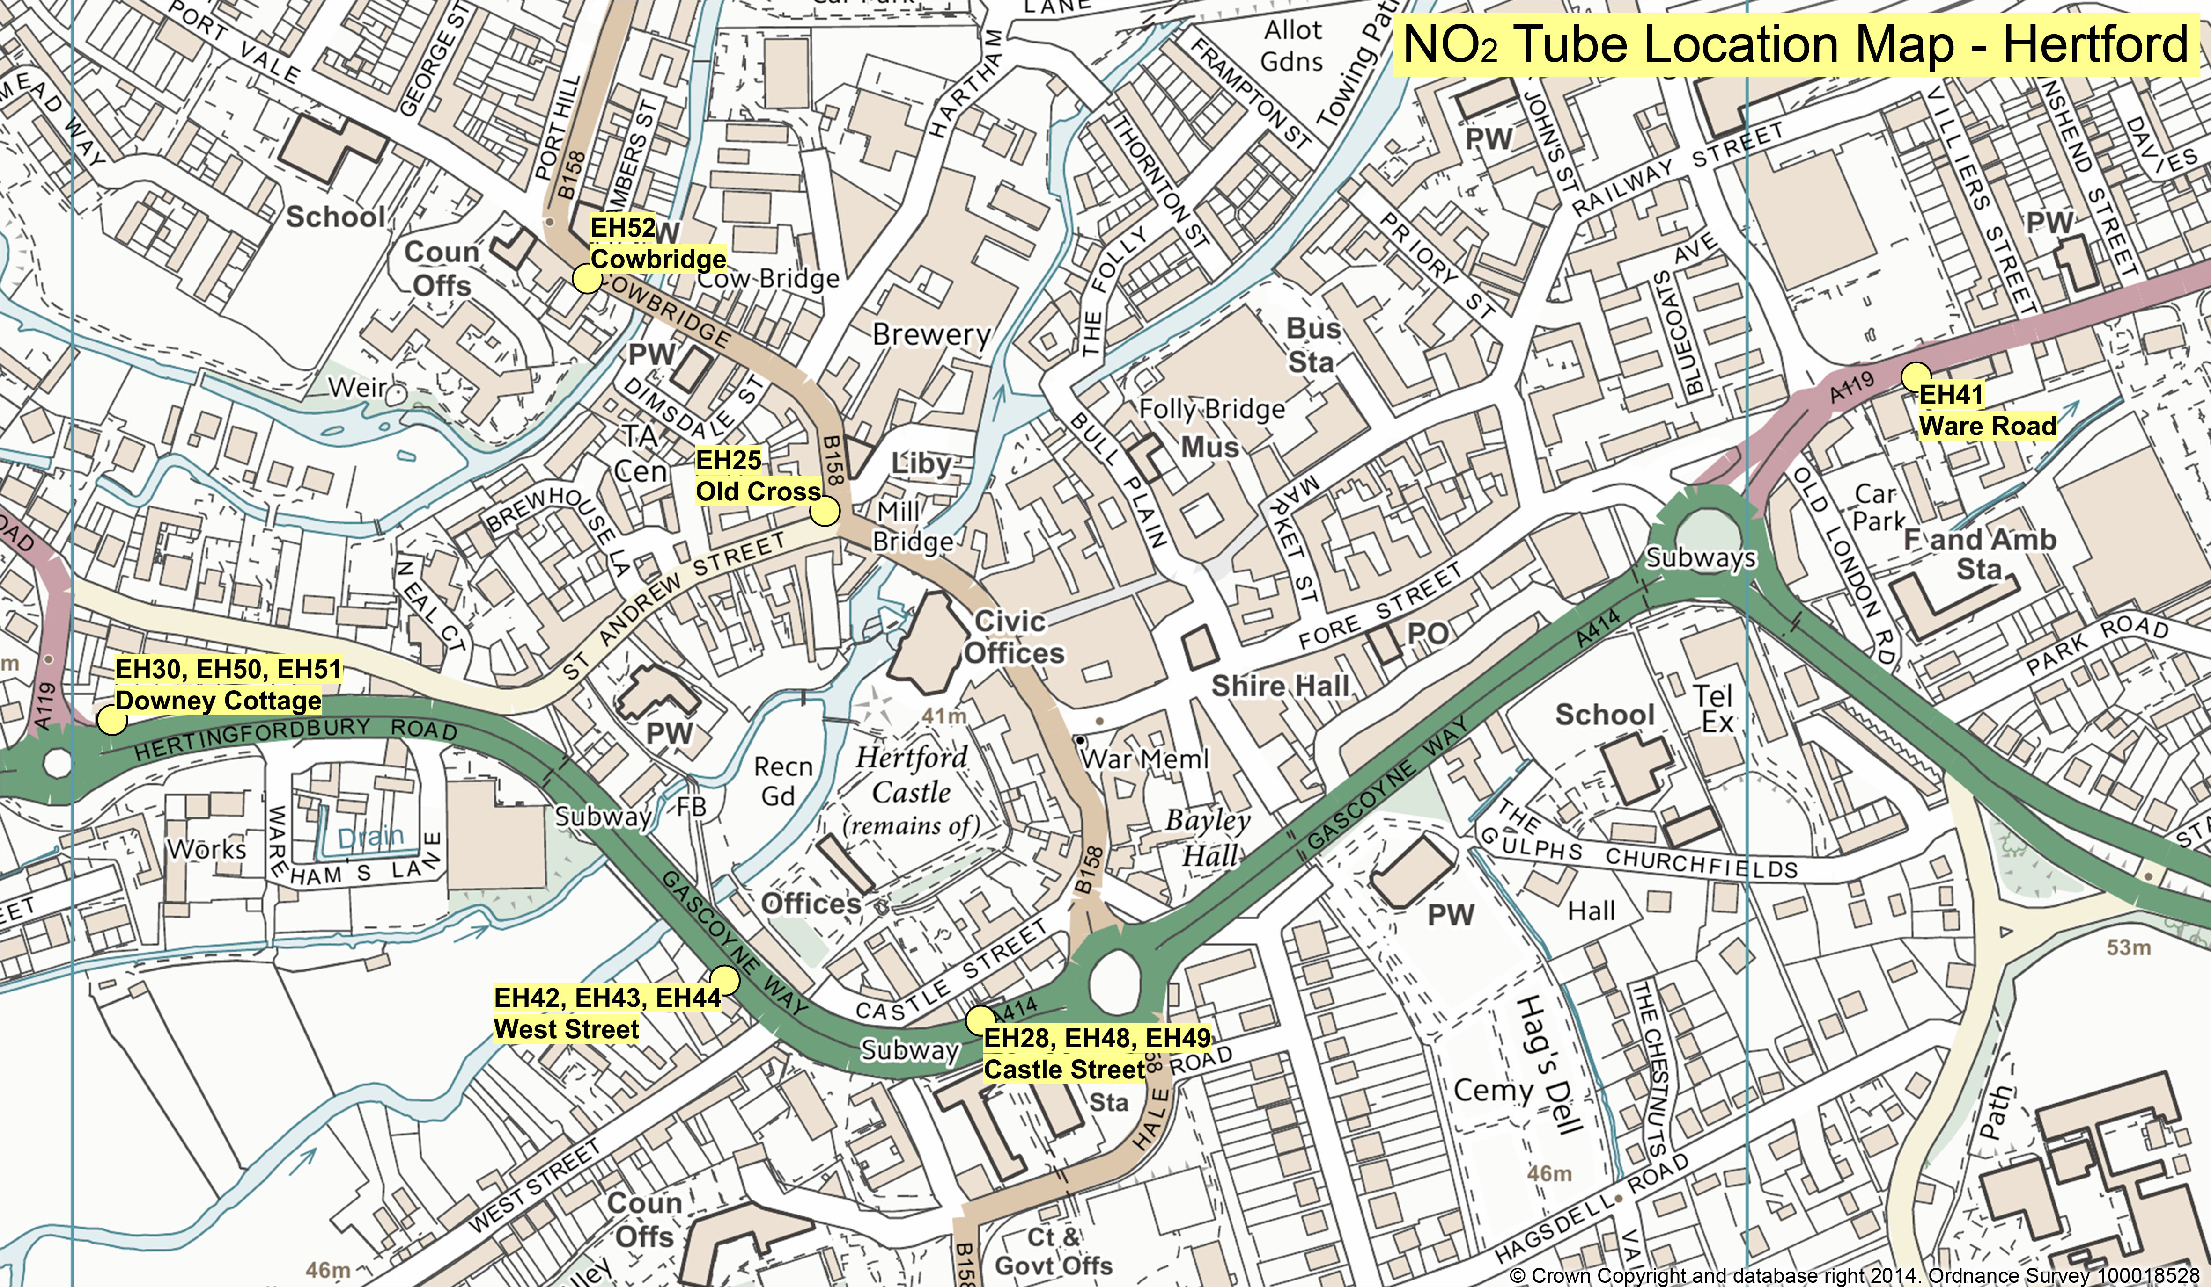

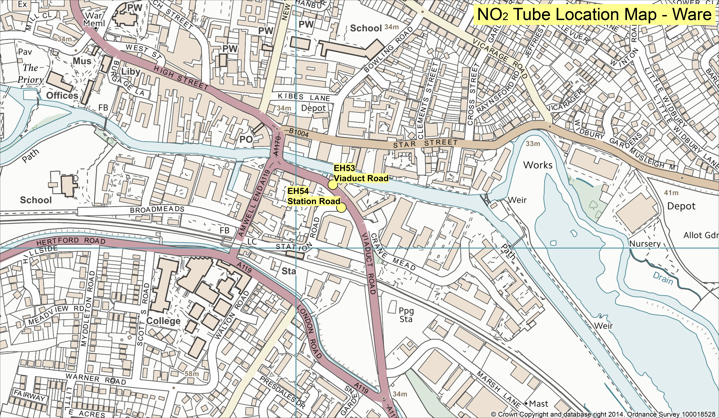

Table 2.2 Details of Non- Automatic Monitoring Sites
Site ID | Site Name | Site Type | X OS Grid Reference | Y OS Grid Reference | Site Height (m) | Pollutants Monitored | In AQMA? | Is Monitoring Co-located with a Continuous Analyser (Y/N) | Relevant Exposure? (Y/N with distance (m) from monitoring site to relevant exposure) | Distance to Kerb of Nearest Road (m) (N/A if not applicable) | Does this Location Represent Worst-Case Exposure?
EH12 | Hockerill Street, Bishop’s Stortford | Roadside | 549156 | 221242 | 2.5 | NO₂ | Y | N | Y (0.9) | 1.38 | Y
EH31 | Hockerill Street, Co-located with EH12 | Roadside | 549156 | 221242 | 2.5 | NO₂ | N | N | Y (0.9) | 1.38 | Y
EH32 | Hockerill Street, Co-located with EH12 | Roadside | 549156 | 221242 | 2.5 | NO₂ | N | N | Y (0.9) | 1.38 | Y
EH14 | London Road, Sawbridgeworth | Roadside | 548065 | 214711 | 3.0 | NO₂ | N* | N | Y (0.6) | 2.6 | Y
EH55 | London Road Sawbridgeworth co-located with EH14 | Roadside | 548065 | 214711 | 3.0 | NO₂ | N* | N | Y (0.6) | 2.6 | Y
EH56 | London Road Sawbridgeworth co-located with EH14 | Roadside | 548065 | 214711 | 3.0 | NO₂ | N* | N | Y (0.6) | 2.6 | Y
EH17 | Dunmow Road, Bishop’s Stortford | Roadside | 549364 | 221215 | 2.75 | NO₂ | N | N | Y (7.4) | 1.8 | Y
EH35 | Dunmow Road, Bishops Stortford Co-located with EH17 | Roadside | 549100 | 221215 | 2.75 | NO₂ | N | N | Y (7.4) | 1.8 | Y
EH36 | Dunmow Road, Bishops Stortford Co-located with EH17 | Roadside | 549364 | 221215 | 2.75 | NO₂ | N | N | Y (7.4) | 1.8 | Y
EH18 | Stansted Road, Bishop’s Stortford | Roadside | 549298 | 221313 | 2.7 | NO₂ | N | N | Y (2.7) | 1.43 | Y
EH37 | Stansted Road, Co-located with EH18 | Roadside | 549298 | 221313 | 2.7 | NO₂ | N | N | Y (2.7) | 1.43 | Y
EH38 | Stansted Road, Co-located with EH18 | Roadside | 549298 | 221313 | 2.7 | NO₂ | N | N | Y (2.7) | 1.43 | Y
EH19 | London Road, Bishop’s Stortford | Roadside | 549250 | 221200 | 2.5 | NO₂ | Y | N | Y (0.4) | 1.05 | Y
EH39 | London Road Co-located with EH19 | Roadside | 549250 | 221200 | 2.5 | NO₂ | Y | N | Y (0.4) | 1.05 | Y
EH40 | London Road Co-located with EH19 | Roadside | 549250 | 221200 | 2.5 | NO₂ | Y | N | Y (0.4) | 1.05 | Y
EH25 | Old Cross, Hertford | Roadside | 532449 | 212675 | 3.0 | NO₂ | Y | N | Y (3.1) | 0.92 | Y
EH28 | Castle Street, Hertford | Roadside | 532542 | 212370 | 2.35 | NO₂ | Y | N | Y (12.5) | 2.39 | Y
EH48 | Castle Street, Hertford  Co-located with EH28 | Roadside | 532542 | 212370 | 2.35 | NO₂ | Y | N | Y (12.5) | 2.39 | Y
EH49 | Castle Street, Hertford  Co-located with EH28 | Roadside | 532542 | 212370 | 2.35 | NO₂ | Y | N | Y (12.5) | 2.39 | Y
EH30 | Downey Cottage, Hertford | Roadside | 532023 | 212550 | 2.35 | NO₂ | Y | N | Y (1.8) | 0.5 $ | Y
EH50 | Downey Cottage, Hertford  Co-located with EH30 | Roadside | 532023 | 212550 | 2.35 | NO₂ | Y | N | Y (1.8) | 0.5 $ | Y
EH51 | Downey Cottage, Hertford  Co-located with EH30 | Roadside | 532023 | 212550 | 2.35 | NO₂ | Y | N | Y (1.8) | 0.5 $ | Y
EH41 | Ware Road, Hertford | Roadside | 533101 | 212755 | 2.3 | NO₂ | Y | N | Y (2.1) | 1.08 | Y
EH42 | West Street Hertford | Roadside | 532389 | 212394 | 2.75 | NO₂ | Y | N | Y (4.8) | 2.75 | Y
EH43 | West Street Hertford Co-located with EH42 | Roadside | 532389 | 212394 | 2.75 | NO₂ | Y | N | Y (4.8) | 2.75 | Y
EH44 | West Street, Hertford Co-located with EH42 | Roadside | 532389 | 212394 | 2.75 | NO₂ | Y | N | Y (4.8) | 2.75 | Y
EH52 | Cowbridge, Hertford | Roadside | 532307 | 212814 | 2.65 | NO₂ | Y | N | Y (1.5) | 3.2 | Y
EH53 | Viaduct Road, Ware | Roadside | 536068 | 214120 | 2.9 | NO₂ | N | N | Y (3.1) | 1.83 | Y
EH54 | Station Road, Ware | Roadside | 536085 | 214077 | 2.6 | NO₂ | N | N | Y (20.7) | 1.75 | Y
EH57 | Junction between Bell Street and London Road Sawbridgeworth | Roadside | 548123 | 214903 | 2.8 | NO₂ | N* | N | Y (0.6) | 2.75 | Y
EH58 | Junction between Bell Street and London Road Sawbridgeworth Co-located with EH57 | Roadside | 548123 | 214903 | 2.8 | NO₂ | N* | N | Y (0.6) | 2.75 | Y
EH59 | Cutforth Road Sawbridgeworth | Kerbside | 548222 | 215395 | 2.2 | NO₂ | N* | N | Y (1.5) £ | 3.0 | Y
EH60 | Cutforth Road Sawbridgeworth Co-located with EH59 | Kerbside | 548222 | 215395 | 2.2 | NO₂ | N* | N | Y (1.5) £ | 3.0 | Y
EH61 | Cutforth Road Sawbridgeworth Co-located with EH59 | Kerbside | 548222 | 215395 | 2.2 | NO₂ | N* | N | Y (1.5) £ | 3.0 | Y
EH62 | Northgate End Bishops Stortford | Roadside | 548723 | 221719 | 2.6 | NO₂ | N | N | Y (6.0) | 2.5 | Y
EH63 | Northgate End Bishops Stortford Co-located with EH62 | Roadside | 548723 | 221719 | 2.6 | NO₂ | N | N | Y (6.0) | 2.5 | Y
EH64 | 79 Rye Street Bishops Stortford | Roadside | 548741 | 222109 | 2.25 | NO₂ | N | N | Y (3.9) | 1.5 | Y
EH65 | 79 Rye Street Bishops Stortford Co-located with EH64 | Roadside | 548741 | 222109 | 2.25 | NO₂ | N | N | Y (3.9) | 1.5 | Y
EH66 | 221 Rye Street Bishops Stortford | Roadside | 549163 | 222731 | 2.5 | NO₂ | N | N | Y (0.5) £ | 1.2 | Y
EH67 | 221 Rye Street Bishops Stortford Co-located with EH66 | Roadside | 549163 | 222731 | 2.5 | NO₂ | N | N | Y (0.5) £ | 1.2 | Y
EH68 | 9 Hadham Road Bishops Stortford | Roadside | 548611 | 221541 | 2.35 | NO₂ | N | N | Y (0.5) | 1.5 | Y
EH69 | 9 Hadham Road Bishops Stortford Co-located with EH68 | Roadside | 548611 | 221541 | 2.35 | NO₂ | N | N | Y (0.5) | 1.5 | Y

N* Denotes where an Air Quality Management Area is to be declared in the near future.
$ Denotes where the nearest road is not thought to be the dominant source of air pollution
£ Denotes where the distance to receptor used is represented by a neighbouring property

Comparison of Monitoring Results with Air Quality Objectives

Nitrogen Dioxide (NO₂)

Automatic Monitoring Data

Both the East Herts Background and East Herts Roadside continuous monitoring stations recorded annual mean concentrations below the 40 µg/m³ threshold. In addition, neither site any hourly means in excess of the 50 µg/m³ objective. A graph showing hourly means can be found in Appendix B.

Table 2.3 Results of Automatic Monitoring for NO₂: Comparison with Annual Mean Objective
Site ID | Site Type | Within AQMA? | Valid Data Capture for Monitoring Period % ª | Valid Data Capture 2013 % ^{b} | Annual Mean Concentration (µg/m³)
 |  |  |  |  | 2009* ^{c} | 2010* ^{c} | 2011* ^{c} | 2012* ^{c} | 2013 ^{c}
EH2 | East Herts  Background | N | 99.6 | 99.6 | 18 | 16 | 16 | 12 | 17
EH3 | East Herts  Roadside | N | 99.5 | 99.5 | 31 | 31 | 30 | 41 | 31
In bold, exceedence of the NO₂ annual mean AQS objective of 40µg/m³
ª i.e. data capture for the monitoring period, in cases where monitoring was only carried out for part of the year
^{b} i.e. data capture for the full calendar year (e.g. if monitoring was carried out for six months the maximum data capture for the full calendar year would be 50%)
^{c} Means should be “annualised” as in Box 3.2 of TG(09) (http://laqm.defra.gov.uk/technical-guidance/index.html?d=page=38), if valid data capture is less than 75%
* Annual mean concentrations for previous years are optional

Figure 2.3 Trends in Annual Mean NO₂ Concentrations Measured at Automatic Monitoring Sites

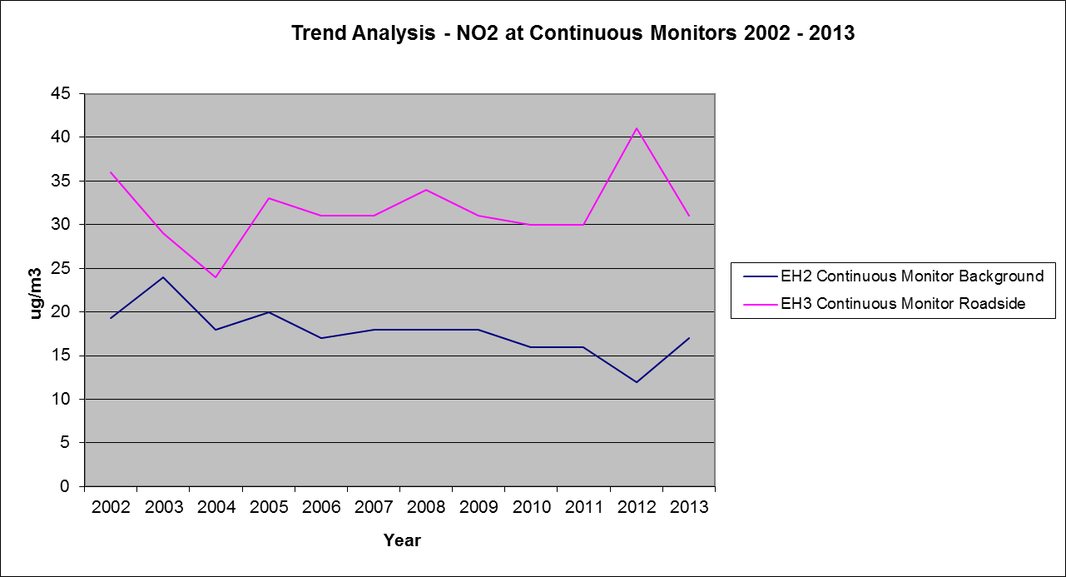

Table 2.4 Results of Automatic Monitoring for NO₂: Comparison with 1-hour Mean Objective
Site ID | Site Type | Within AQMA? | Valid Data Capture for Monitoring Period % ª | Valid Data Capture 2013 % ^{b} | Number of Hourly Means > 200µg/m³
 |  |  |  |  | 2009* ^{c} | 2010* ^{c} | 2011* ^{c} | 2012* ^{c} | 2013 ^{c}
EH2 | East Herts  Background | N | 99.6 | 99.6 | 0 | 0 | 0 | 0 | 0
EH3 | East Herts  Roadside | N | 99.5 | 99.5 | 0 | 0 | 0 | 0 | 0
In bold, exceedence of the NO₂ hourly mean AQS objective (200µg/m³ – not to be exceeded more than 18 times per year)
ª i.e. data capture for the monitoring period, in cases where monitoring was only carried out for part of the year
^{b} i.e. data capture for the full calendar year (e.g. if monitoring was carried out for six months the maximum data capture for the full calendar year would be 50%)
^{c} If the data capture for full calendar year is less than 90%, include the 99.8th percentile of hourly means in brackets
* Number of exceedences for previous years is optional

Diffusion Tube Monitoring Data

East Herts currently have a network of 42 nitrogen dioxide diffusion tubes (in 19 locations), 11 of these locations exceed the annual mean objective of 40µg/m³. 9 of these locations are already in an AQMA, and the remaining 2 are located in an area that is to be declared as an AQMA in the near future. 4 of the 9 locations in the AQMA recorded annual means in excess of 60µg/m³ which indicates a possible exceedence of the hourly objective. 2 of these locations are located within the Hockerill junction AQMA, 1 in the Hertford AQMA, and the other within an area of Sawbridgeworth soon to be included in an AQMA. Where diffusion tubes are located in duplicate or triplicate, the results presented in Table 2.5 have been averaged. However the result for each individual diffusion tube has been given in Appendix C.

One location in Viaduct road Ware recorded an annual mean of 40µg/m³. As the level at the nearest receptor would be less and therefore under the objective, and another tube located opposite this one recorded an annual mean of 30µg/m³, it was considered appropriate to keep a watching brief on this area

Table 2.5 Results of NO₂ Diffusion Tubes 2013
Site ID | Location | Site Type | Within AQMA? | Triplicate or Co-located Tube | Full Calendar Year Data Capture 2013 (Number of Months or %) ª | 2013 Annual Mean Concentration (µg/m³) - Bias Adjustment factor = 0.95 ^{b}
EH12  EH31  EH32 | Hockerill Street, Bishops Stortford | roadside | Y | Triplicate | 12  12  12 | 49
EH14  EH55  EH56 | London Road, Sawbridgeworth | roadside | N | Triplicate | 12  12  12 | 52
EH17  EH35 EH36 | Dunmow Road, Bishops Stortford | kerbside | Y | Triplicate | 12  12  12 | 74
EH18  EH37 EH38 | Stansted Road, Bishops Stortford | roadside | Y | Triplicate | 12  12  12 | 41
EH19  EH39  EH40 | London Road Bishops Stortford | roadside | Y | Triplicate | 12  12  12 | 76
EH25 | Old Cross Hertford | kerbside | Y |  | 12 | 44
EH28  EH48  EH49 | Castle St Hertford | roadside | Y | Triplicate | 12  12  12 | 48
EH30  EH50  EH51 | Downey Cottage Hertingfordbury Rd | roadside | Y | Triplicate | 12  12  12 | 45
EH41 | Ware Rd Hertford | roadside | Y |  | 12 | 52
EH42  EH43  EH44 | West St Hertford | roadside | Y | Triplicate | 12  12  12 | 64
EH52 | Cowbridge Hertford | roadside | N |  | 12 | 32
EH53 | Viaduct Road Ware | roadside | N |  | 12 | 40
EH54 | Station Road Ware | roadside | N |  | 12 | 30
EH57  EH58 | Opposite Bell Street Sawbridgeworth at crossing | roadside | N | Duplicate | 12  12 | 65
EH59  EH60  EH61 | Cutforth Road Sawbridgeworth | Kerbside | N | Triplicate | 10  10 | 33
EH62  EH63 | Northgate End Bishops Stortford | Roadside | N | Duplicate | 5  6 | 35*
EH64  EH65 | 79 Rye Street Bishops Stortford | Roadside | N | Duplicate | 7  7 | 39*
EH66  EH67 | 209 Rye Street Bishops Stortford | Roadside | N | Duplicate | 7  7 | 22*
EH68  EH69 | 9 Hadham Road Bishops Stortford | Roadside | N | Duplicate | 7  7 | 39*
In bold, exceedence of the NO₂ annual mean AQS objective of 40µg/m³
Underlined, annual mean > 60µg/m³, indicating a potential exceedence of the NO₂ hourly mean AQS objective
ª Means should be “annualised” as in Box 3.2 of TG(09)( http://laqm.defra.gov.uk/technical-guidance/index.html?d=page=38), if full calendar year data capture is less than 75%
^{b} If an exceedence is measured at a monitoring site not representative of public exposure, NO₂ concentration at the nearest relevant exposure should be estimated based on the “NO₂ fall-off with distance” calculator (http://laqm.defra.gov.uk/tools-monitoring-data/no2-falloff.html), and results should be discussed in a specific section. The procedure is also explained in Box 2.3 of Technical Guidance LAQM.TG(09) (http://laqm.defra.gov.uk/technical-guidance/index.html?d=page=30).
*Denotes Annual Means that have been annualised. See Appendix for details of calculation.

Table 2.6 Results of NO₂ Diffusion Tubes (2009 to 2013)
Site ID | Site Type | Within AQMA? | Annual Mean Concentration (µg/m³) - Adjusted for Bias ª
Site ID | Site Type | Within AQMA? | 2009 (Bias Adjustment Factor = 0.90) | 2010 (Bias Adjustment Factor = 0.96) | 2011 (Bias Adjustment Factor = 0.89) | 2012 (Bias Adjustment Factor = 0.97) | 2013 (Bias Adjustment Factor = 0.95)
EH12 | roadside | Y | 53 | 45 | 46 | 46 | 49
EH14 | roadside | N | 53 | 46 | 42 | 47 | 52
EH17 | kerbside | Y | 66 | 66 | 59 | 60 | 74
EH18 | roadside | Y | 45 | 39 | 36 | 41 | 39
EH19 | roadside | Y | 71 | 69 | 66 | 67 | 75
EH25 | kerbside | Y | 42 | 41 | 40 | 39 | 44
EH28 | roadside | Y | 44 | 40 | 42 | 38 | 50
EH30 | roadside | Y | 46 | 41 | 42 | 40 | 45
EH31 | roadside | Y | 55 | 46 | N/A | 46 | 50
EH32 | roadside | Y | 55 | 45 | 44 | 48 | 48
EH35 | kerbside | Y | 65 | 68 | 59 | 65 | 74
EH36 | kerbside | Y | 69 | 64 | 61 | 59 | 73
EH37 | roadside | Y | 45 | 40 | 37 | 38 | 42
EH38 | roadside | Y | 43 | 41 | 35 | 38 | 41
EH39 | roadside | Y | 73 | 69 | 65 | 66 | 77
EH40 | roadside | Y | 75 | 72 | 67 | 65 | 77
EH41 | roadside | Y | 49 | 44 | 44 | 47 | 52
EH42 | roadside | N | 67 | 51 | 56 | 59 | 66
EH43 | roadside | N | 68 | 55 | 60 | 56 | 65
EH44 | roadside | N | 66 | 59 | 55 | 61 | 61
EH48 | roadside | Y | 45 | 40 | 38 | 38 | 46
EH49 | roadside | Y | 45 | 41 | 39 | 38 | 47
EH50 | roadside | Y | 46 | 40 | 39 | 39 | 46
EH51 | roadside | N | 44 | 40 | 38 | 39 | 45
EH52 | roadside | N | 35 | 31 | 32 | 31 | 32
EH53 | roadside | N | N/A | 38 | 36 | 38 | 40
EH54 | roadside | N | N/A | 34 | 28 | 29 | 30
EH55 | roadside | N | N/A | 44 | 43 | 47 | 53
EH56 | roadside | N | N/A | 49 | 43 | 46 | 50
EH57 | roadside | N | N/A | 67 | 56 | 61 | 66
EH58 | roadside | N | N/A | N/A | 55 | 59 | 65
EH59 | roadside | N | N/A | N/A | N/A | N/A | 34
EH60 | roadside | N | N/A | N/A | N/A | N/A | 34
EH61 | roadside | N | N/A | N/A | N/A | N/A | 33
EH62 | roadside | N | N/A | N/A | N/A | N/A | 33
EH63 | roadside | N | N/A | N/A | N/A | N/A | 37
EH64 | roadside | N | N/A | N/A | N/A | N/A | 38
EH65 | roadside | N | N/A | N/A | N/A | N/A | 40
EH66 | roadside | N | N/A | N/A | N/A | N/A | 22
EH67 | roadside | N | N/A | N/A | N/A | N/A | 22
EH68 | roadside | N | N/A | N/A | N/A | N/A | 38
EH69 | roadside | N | N/A | N/A | N/A | N/A | 39
In bold, exceedence of the NO₂ annual mean AQS objective of 40µg/m³
Underlined, annual mean > 60µg/m³, indicating a potential exceedence of the NO₂ hourly mean AQS objective
ª Means should be “annualised” as in Box 3.2 of TG(09) (http://laqm.defra.gov.uk/technical-guidance/index.html?d=page=38), if full calendar year data capture is less than 75%

Figure 2.4 Trends in Annual Mean Nitrogen Dioxide Concentrations Measured at Diffusion Tube Monitoring Sites

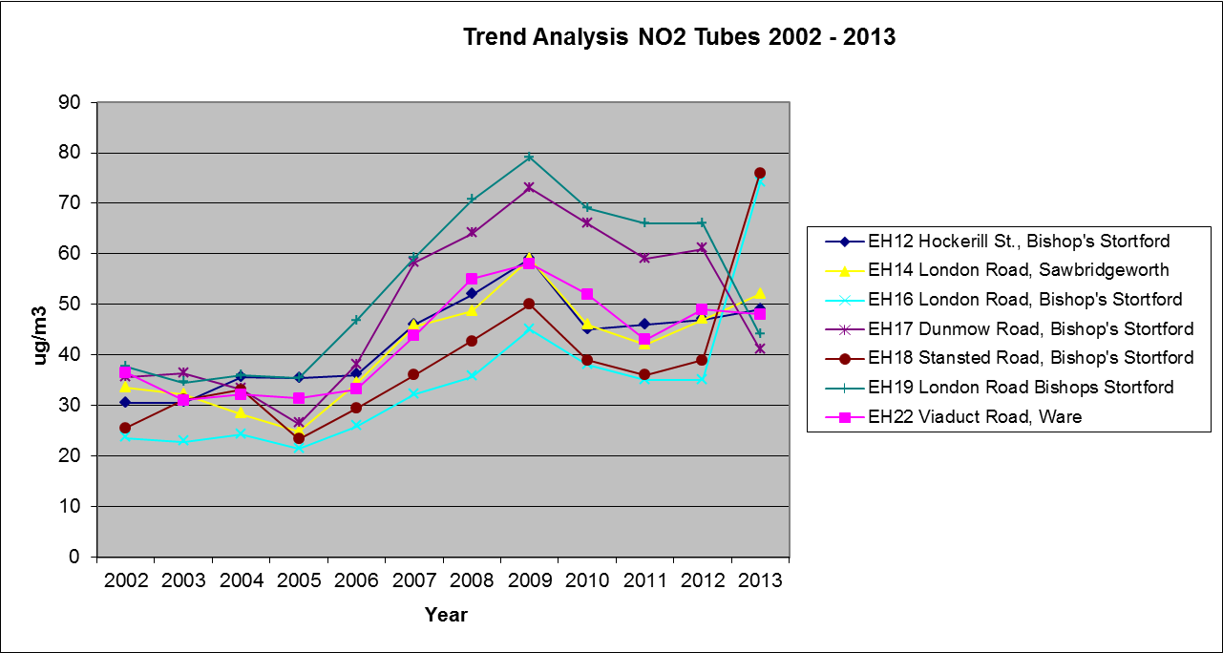

Particulate Matter (PM₁₀)

East Herts Council met the annual objective and the 24 hour mean objective for PM10 at all locations monitored.

Table 2.7 Results of Automatic Monitoring for PM₁₀: Comparison with Annual Mean Objective
Site ID | Site Type | Within AQMA? | Valid Data Capture for Monitoring Period % ª | Valid Data Capture 2013 % ^{b} | Confirm Gravimetric Equivalent (Y or N/A) | Annual Mean Concentration (µg/m³)
 |  |  |  |  |  | 2009* ^{c} | 2010* ^{c} | 2011* ^{c} | 2012* ^{c} | 2013 ^{c}
EH2 | East Herts  Background | N | 95.1 | 95.1 | Y | 17 | 17 | 14 | 13 | 18
EH3 | East Herts  Roadside | N | 95.5 | 95.5 | Y | 21 | 23 | 21 | 25 | 24
In bold, exceedence of the PM₁₀ annual mean AQS objective of 40µg/m³
ª i.e. data capture for the monitoring period, in cases where monitoring was only carried out for part of the year
^{b} i.e. data capture for the full calendar year (e.g. if monitoring was carried out for six months the maximum data capture for the full calendar year would be 50%)
^{c} Means should be “annualised” as in Box 3.2 of TG(09) (http://laqm.defra.gov.uk/technical-guidance/index.html?d=page=38), if valid data capture is less than 75%
* Annual mean concentrations for previous years are optional

Figure 2.5 Trends in Annual Mean PM₁₀ Concentrations

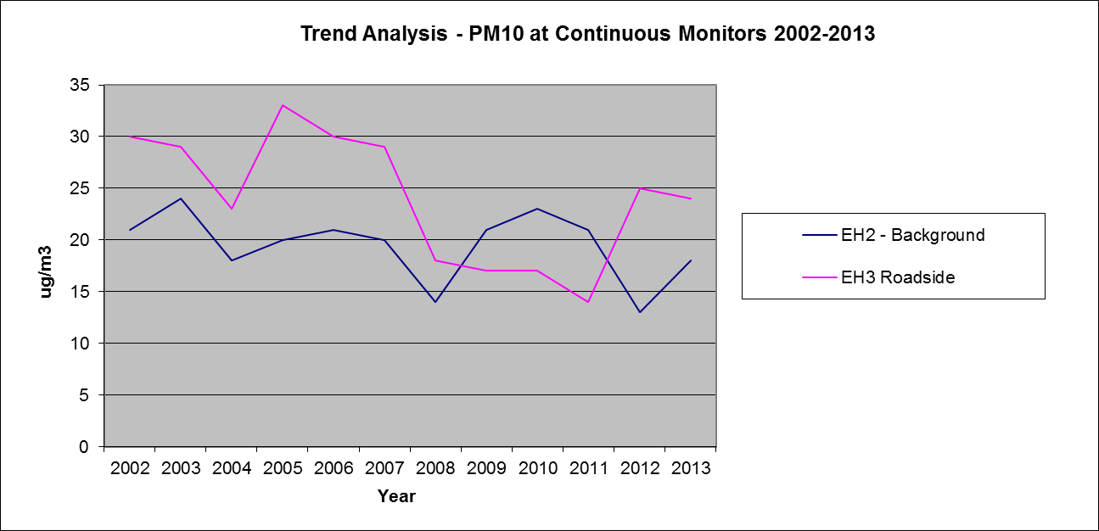

Table 2.8 Results of Automatic Monitoring for PM₁₀: Comparison with 24-hour Mean Objective
Site ID | Site Type | Within AQMA? | Valid Data Capture for Monitoring Period % ª | Valid Data Capture 2013 % ^{b} | Confirm Gravimetric Equivalent (Y or N/A) | Number of Daily Means > 50µg/m³
 |  |  |  |  |  | 2009* ^{c} | 2010* ^{c} | 2011* ^{c} | 2012* ^{c} | 2013 ^{c}
EH2 | East Herts  Background | N | 95.1 | 95.1 | Y | 0 | 0 | 0 | 14 | 2
EH3 | East Herts  Roadside | N | 95.5 | 95.5 | Y | 0 | 0 | 0 | 4 | 6
In bold, exceedence of the PM₁₀ daily mean AQS objective (50µg/m³ – not to be exceeded more than 35 times per year)
ª i.e. data capture for the monitoring period, in cases where monitoring was only carried out for part of the year
^{b} i.e. data capture for the full calendar year (e.g. if monitoring was carried out for six months the maximum data capture for the full calendar year would be 50%)
^{c} if data capture for full calendar year is less than 90%, include the 90.4th percentile of 24-hour means in brackets
* Number of exceedences for previous years is optional

Sulphur Dioxide (SO₂)

East Herts Council does not monitor Sulphur Dioxide

Benzene

East Herts Council does not monitor Benzene

Other Pollutants Monitored

Ozone has been monitored in a rural school in Anstey since January 2011. Ozone is not emitted directly from any man made source in significant quantities, but is formed by a complex set of reactions involving nitrogen oxides and hydrocarbons in the presence of light from the sun. Once formed, ozone can remain in atmosphere for many days and is often transported over long distances. It is for this reason that a real reduction in ozone levels can only be achieved through global action by everyone. Ozone is therefore not a pollutant currently in the Air Quality Regulations. It is however still considered when looking at air Quality. The results of the ozone monitoring for 2013 are given below:

Table 2.9 Results of Automatic Monitoring for Ozone

Air Quality (England) Regulations 2000 & (Amendment) Regulations 2002 | Max. Concentration | Number | Days | Allowed | Exceeded
Daily max run 8hr mean > 100 µg/m³ | 159 µg/m³ | 24 | 24 | 10 days | yes

Summary of Compliance with AQS Objectives
East Herts Council has examined the results from monitoring in the district.

Concentrations within the AQMA still exceed the annual objective for Nitrogen Dioxide at Hockerill Junction, Bishop’s Strotford and Gascoyne Way, Hertford and the AQMAs should remain.

An AQMA is to be declared at London Road, Sawbridgeworth.

Concentrations outside of the AQMA are all below the objectives at relevant locations, therefore there is no need to proceed to a Detailed Assessment.

New Local Developments

Road Traffic Sources

East Herts has not identified any new road traffic sources since the last updating and screening assessment.

Other Transport Sources

There have been no changes since the previous Updating and Screening Assessment that would require East Herts to carry out an assessment on the following:

- Airports.
- Locations where diesel or steam trains are regularly stationary for periods of 15 minutes or more, with potential for relevant exposure within 15m.
- Locations with a large number of movements of diesel locomotives, and potential long-term relevant exposure within 30m.
- Ports for shipping.

Industrial Sources

East Herts has not identified any of the following since the last Updating and Screening Assessment that would require further assessment.

- Industrial installations: new or proposed installations for which an air quality assessment has been carried out.
- Industrial installations: existing installations where emissions have increased substantially or new relevant exposure has been introduced.
- Industrial installations: new or significantly changed installations with no previous air quality assessment.
- Major fuel storage depots storing petrol.
- Petrol stations

Commercial and Domestic Sources

East Herts Council are not aware of any new biomass combustion plants or a significant increase in the use of domestic solid fuel burning since publication of the Updating and Screening Assessment in 2012.
.

New Developments with Fugitive or Uncontrolled Sources

East Herts Council has not identified any of the following sources that require further assessment since the previous Updating and Screening Assessment.

- Biomass combustion plant – individual installations.
- Areas where the combined impact of several biomass combustion sources may be relevant.
- Areas where domestic solid fuel burning may be relevant.

East Herts Council confirms that there are no new or newly identified local developments which may have an impact on air quality within the Local Authority area.
East Herts Council confirms that all the following have been considered:

- Road traffic sources
- Other transport sources
- Industrial sources
- Commercial and domestic sources
- New developments with fugitive or uncontrolled sources.

Local / Regional Air Quality Strategy
East Herts Council does not have an Air Quality Strategy

Planning Applications

The following application has been approved pending s106 agreements since the Porgress report in 2013

Main Location | Land at Bishop's Stortford North, Bishop’s Stortford, Herts
Proposal | Erection of up to 2,200 dwellings inclusive of affordable housing; green infrastructure, amenity and formal and informal recreation space; landscaping; development of 2 mixed use local centres on 4.1 hectares of land providing up to 21,000 sq.m. (gross) commercial floorspace (Use Class B1 a, b and c) inclusive of (if required) a maximum of 3,000 sq.m. (gross) for a healthcare facility (Use Class D1) together with retail floorspace (Use Classes A1, A2, A3, A4 & A5) up to a maximum of 1,200 sq.m. (gross) and the potential for other community/cultural/leisure (Use Class D1 & D2) If required (floorspace to be agreed); two primary schools and associated facilities; a park and ride facility for approximately 100 vehicles; 4 new junctions (A120, Hadham Road, Rye Street and Farnham Road); estate roads and public transport route (including a link along Dane O'Coys Road); footpaths/cycleways; site profiling/earthworks; a noise bund with barrier; a sustainable drainage system; utilities services including foul water pumping stations; 2 residential garden extensions; and the demolition of 221 Rye Street and 164 & 165 Hadham Road (all matters reserved except vehicular access)

Air Quality Planning Policies
East Herts Council is currently preparing its District Plan which will contain Environmental Quality policies including those relating to air quality. Public consultation on the District Plan took place between February and May 2014. Further public consultation will take place next year with possible subsequent adoption of the document by 2016.

Current planning policies for East Herts are set out in the ‘East Herts Local Plan Second Review 2007 Saved Policies Version’ and include policy ENV27 Air Quality which considers the impact of development on air quality and refers to AQMAs.

Local Transport Plans and Strategies

East Herts Council is currently working with Hertfordshire County Council in the revision of the joint Air Quality Action Plan to ensure that suitable actions are incorporated into this Progress Report to reduce the pollution in the newly extended AQMA in Hertford. The Action Plan also aims to reduce overall pollution throughout the district.
East Herts Council will assist Hertfordshire County Council with the implementation of the current joint Air Quality Action Plan and the reporting of these actions. The joint Air Quality Action Plan is integrated into the Local Transport Plan as an appendix to the Local Transport Plan Annual Progress Report (www.hertsdirect.org/ltp).

Climate Change Strategies
East Herts Council recognises that climate change will bring challenges and opportunities, and that action is needed now, both to reduce emissions of global warming gases in order to help reduce more serious changes in the future (often referred to as mitigation), and to help us to prepare for those impacts of climate change that are already unavoidable (adaptation).

The strategy document describes briefly the causes of climate change and the changes that are likely to be experienced by the District of East Herts. The strategy consolidates East Herts Council’s response to climate change as a signatory to the Nottingham Declaration (see below).

The strategy defines the scope and objectives of the Council’s activities in the context of actions being undertaken by other agencies. It comprises a review of actions that the District Council is already undertaking, and proposes additional measures to tackle the causes and impacts of climate change.

For ease of communication and implementation, current and proposed actions have been grouped under a series of topics that loosely reflect the Council’s relevant service areas.

Each section includes a description of how service areas can mitigate the causes of climate change and how the service areas will be affected by climate change. The proposed actions have been assigned to named sections of the Authority for implementation.

Each action plan focuses primarily on measures to mitigate climate change by reducing emissions of greenhouse gases. Where applicable, however, actions have been included that relate to adaptation - enabling the Council or wider District to better withstand the anticipated effects of climate change. Further work is proposed on adaptation, identifying risks to the District.

The Action Plan contains a mix of one-off short-term measures that should bring quick wins and more strategic proposals for longer-term but ultimately further-reaching effects.

It is intended that the Action Plan will be monitored on an annual basis to ensure that targets are being met wherever possible. In addition, an annual audit of carbon dioxide (or carbon dioxide equivalents) emissions arising through the Council’s operations will be undertaken to evaluate the effectiveness of the Council’s actions in reducing its contribution to climate change. The results of this “Carbon Footprint” will be publicised.

The Council’s Climate Change Strategy can be found on www.eastherts.gov.uk

Implementation of Action Plans
The joint Herts County Council Local Transport Plan and East Herts Council Action Plan Progress report is currently under review

Conclusions and Proposed Actions

Conclusions from New Monitoring Data

The 2014 Progress Report has nor identified any exceedances that has not been previously considered and assessed in previous reports.

Conclusions relating to New Local Developments

Bishop’s Stortford North has been given planning permission pending s106 agreements. This development will be considered in more detail in the next Updating and Screening Assessment.

Other Conclusions

East Herts Council has carried out several projects over the year including the development of a teaching pack for secondary schools. A progress report for the action plan needs to be written to reflect these achievements,

Proposed Actions

The Air Quality Management Area for Sawbridgeworth will be declared before the end of January 2015.

References

- Part IV of Environment Act 1995: Local Air Quality Management. Technical Guidance LAQM.TG (09). Defra, February 2009.
- The Air Quality (England) Regulations 2000 (Statutory Instrument 2000 No. 928), March 2000.
- The Air Quality Strategy for England, Scotland, Wales and Northern Ireland. January 2000. ISBN 0-10-145482-1
- The Air Quality Amendment Regulations 2002, ISBN 0 11061468 2.

Appendices
Appendix A: QA:QC Data

- Diffusion Tube Bias Adjustment Factors

The National Diffusion Tube Bias Adjustment Spreadsheet calculated 0.95 as the Bias Adjustment figure for 2013 where tubes are provided by Gradko and use a 20% TEA in Water preparation.

- Factor from Local Co-location Studies

The Precision and Accuracy table below shows the monthly results of the triplicate diffusion tubes at Cutforth Road. These are used to calculate the local bias adjustment factor. It is calculated to be 0.84.
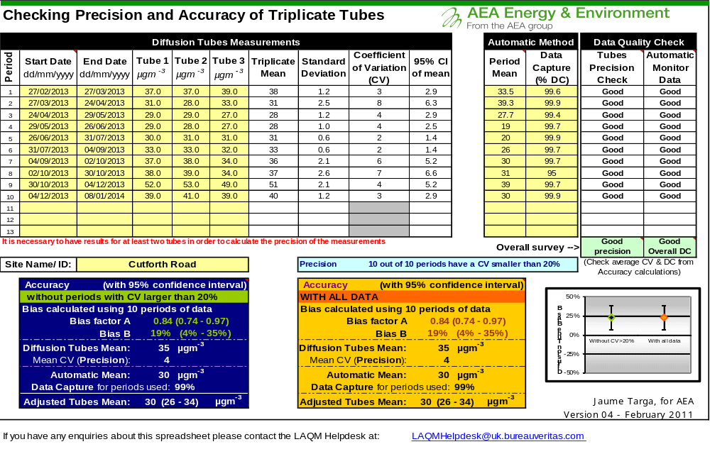

PASTE SPREADSHEET “C” HERE

- Discussion of Choice of Factor to Use

Luton Borough Council has calculated a local bias adjustment factor of 0.93. The national bias adjustment factor that was calculated from Gradko tubes of the same
This information was also fed into the national bias adjustment survey in order to calculate a national bias adjustment figure for all similar Gradko tubes.

- Discussion of Choice of Factor to Use

The bias adjustment factor used in this report was the one produced by the national bias adjustment survey. This factor was higher than the local factor and therefore would result in higher concentrations being reported than if the lower locally derived figure had been used. This ensures that the progress report is conservative,

- PM Monitoring Adjustment

Results obtained from the TEOM anlysers were corrected using the Kings College Volatile Correction Model (VCM). This model allows the correction of TEOM measurements for the loss of volatile components of particulate matter that occur due to the high sampling temperatures employed by this instrument. The resulting corrected measurements have been demonstrated as equal to the gravimetric reference equivalent.

This calculation was undertaken by Air Quality Data Management (AQDM).

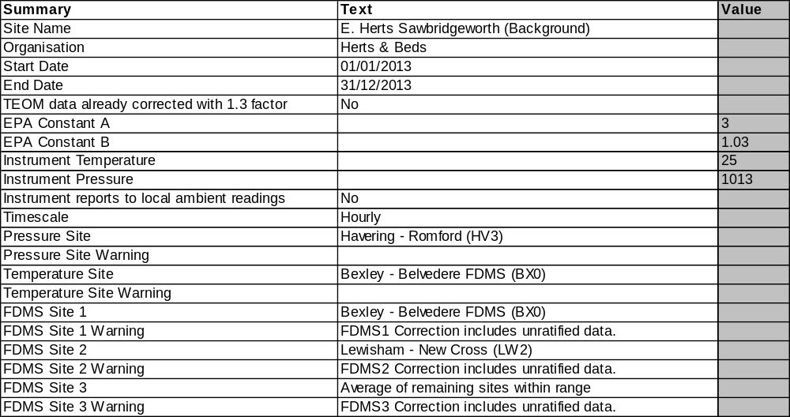
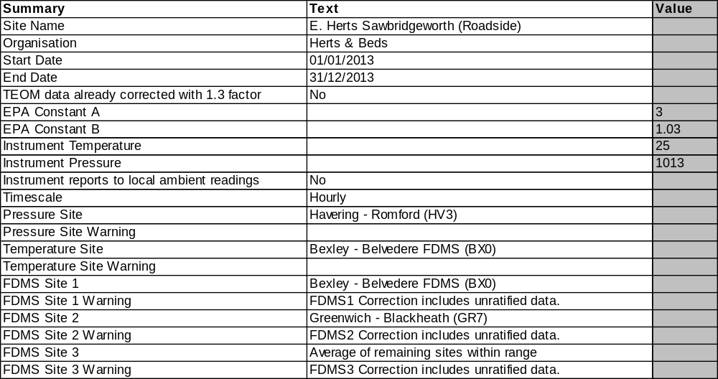

- Short-term to Long-term Data adjustment

The following calculations have been undertaken to estimate the annual mean concentrations at the locations where nitrogen dioxide monitoring commenced part way through the year. The following sites were chosen as they are nearest and most appropriate.

Table A.1 Short-Term to Long-Term Monitoring Data Adjustment
Where:
AURN 1 | Thurrock BG Urban
AURN 2 | Wicken Fen
AURN 3 | Northampton Kingsthorpe

EH62 Northgate End B/S Jct Yew Tree Court
Site | Site Type | Annual Mean (µg/m³) | Period Mean (µg/m³) | Ratio
AURN1 | Urban Background | 27.1 | 28.1 | 0.964461
AURN2 | Rural | 9.7 | 11.9 | 0.818389
AURN3 | Urban Background | 14.0 | 17.4 | 0.805521
Average |  |  |  | 0.86279

EH63 Northgate End B/S Jct Yew Tree Court c/loc EH62
Site | Site Type | Annual Mean (µg/m³) | Period Mean (µg/m³) | Ratio
AURN1 | Urban Background | 27.1 | 26.8 | 1.008513
AURN2 | Rural | 9.7 | 10.7 | 0.904496
AURN3 | Urban Background | 14.0 | 15.7 | 0.890643
Average |  |  |  | 0.934551

EH64 Rye St, B/S outside 79
Site | Site Type | Annual Mean (µg/m³) | Period Mean (µg/m³) | Ratio
AURN1 | Urban Background | 27.1 | 25.5 | 1.059717
AURN2 | Rural | 9.7 | 10.0 | 0.971197
AURN3 | Urban Background | 14.0 | 14.5 | 0.9696
Average |  |  |  | 1.000172

EH65 Rye St, B/S outside 79 c/loc EH64
Site | Site Type | Annual Mean (µg/m³) | Period Mean (µg/m³) | Ratio
AURN1 | Urban Background | 27.1 | 25.5 | 1.059717
AURN2 | Rural | 9.7 | 10.0 | 0.971197
AURN3 | Urban Background | 14.0 | 14.5 | 0.9696
Average |  |  |  | 1.000172

EH66 Rye St, B/S outside 221
Site | Site Type | Annual Mean (µg/m³) | Period Mean (µg/m³) | Ratio
AURN1 | Urban Background | 27.1 | 25.5 | 1.059717
AURN2 | Rural | 9.7 | 10.0 | 0.971197
AURN3 | Urban Background | 14.0 | 14.5 | 0.9696
Average |  |  |  | 1.000172

EH67 Rye St, B/S outside 221 c/loc EH66
Site | Site Type | Annual Mean (µg/m³) | Period Mean (µg/m³) | Ratio
AURN1 | Urban Background | 27.1 | 25.5 | 1.059717
AURN2 | Rural | 9.7 | 10.0 | 0.971197
AURN3 | Urban Background | 14.0 | 14.5 | 0.9696
Average |  |  |  | 1.000172

EH68 Hadham Rd, B/S outside 9
Site | Site Type | Annual Mean (µg/m³) | Period Mean (µg/m³) | Ratio
AURN1 | Urban Background | 27.1 | 25.5 | 1.059717
AURN2 | Rural | 9.7 | 10.0 | 0.971197
AURN3 | Urban Background | 14.0 | 14.5 | 0.9696
Average |  |  |  | 1.000172

EH69 Hadham Rd, B/S outside 9 c/loc EH68
Site | Site Type | Annual Mean (µg/m³) | Period Mean (µg/m³) | Ratio
AURN1 | Urban Background | 27.1 | 25.5 | 1.059717
AURN2 | Rural | 9.7 | 10.0 | 0.971197
AURN3 | Urban Background | 14.0 | 14.5 | 0.9696
Average |  |  |  | 1.000172

- QA/QC of Automatic Monitoring

Officers from East Herts Council undertook calibrations of the analysers in 2013. SupportingU were contracted to undertake 6 monthly calibration and maintenance all analysers.

Results were validated and ratified by Air Quality Data Management (AQDM) who has provided this information regarding the procedures used:

Air quality measurements from automatic instruments are ratified to the standards described in the Local Air Quality Management – Technical Guidance LAQM TG(09) http://www.defra.gov.uk/publications/2011/03/25/pb13081-laqm-technical-guidance-tg09.

Validation
This process operates on data during the data collection stage. All data are continually screened algorithmically and manually for anomalies. There are several techniques designed to discover spurious and unusual measurements within a very large dataset. These anomalies may be due to equipment failure, human error, power failures, interference or other disturbances Automatic screening can only safely identify spurious results that need further manual investigation.

Raw data from the gaseous instruments (e.g. NOx, O3, SO2 and CO) are scaled into concentrations using the latest values derived from the manual and automatic calibrations. These instruments are not absolute and suffer drifts. Both the zero baseline (background) and the sensitivity change with time. Regular calibrations with certified gas standards are used to measure the zero and sensitivity. However, these are only valid for the moment of the calibration since the instrument will continue to drift. Raw measurements from particulate instruments (e.g. PM10 and PM2.5) generally do not require scaling into concentrations. The original raw data are always preserved intact while the processed data are dynamically scaled and edited.

Ratification
This is the process that finalises the data to produce the measurements suitable for reporting. All available information is critically assessed so that the best data scaling is applied and all anomalies are appropriately edited. Generally this operates at three, six or twelve month intervals. However, unexpected faults can be identified during the instrument routine services or independent audits which are often at 6-monthly intervals. In practice, therefore, the data can only be fully ratified in 12-month or annual periods. The data processing performed during the three and six monthly cycles helps build a reliable dataset that is finalised at the end of the year.

There is a diverse range of additional information that can be essential to the correct understanding and editing of data anomalies. These may include
• the correct scaling of data
• ignoring calibrations that were poor e.g. a spent zero scrubber
• closely tracking rapid drifts or eliminating the data
• comparing the measurements with other pollutants and nearby sites
• corrections due to span cylinder drift
• corrections due to flow drifts for the particulate instruments
• corrections for ozone instrument sensitivity drifts
• eliminating measurements for NO2 conversion inefficiencies
• eliminating periods where calibration gas is in the ambient dataset
• identifying periods were instruments are warming-up after a power cut
• identification of anomalies due to mains power spikes
• correcting problems with the date and time stamp
• observations made during the sites visits and services

The identification of data anomalies, the proper understanding of the effects and the application of appropriate corrections requires expertise gained over many years of operational experience. Instruments and infrastructure can fail in numerous ways that significantly and visually affect the quality of the measurements. There are rarely simple faults that can be discovered by computer algorithms or can be understood without previous experience.

Further information about air quality data management, expert data ratification and examples of bad practices are given on the Air Quality Data Management (AQDM) website http://www.aqdm.co.uk.

- QA/QC of Diffusion Tube Monitoring

The precision and accuracy of diffusion tubes deployed by East Herts Council is shown in Appendix A.2.
Tubes deployed by the Council are obtained from Gradko International Ltd. using a preparation of 20% TEA in deionised water. The performance of Gradko is monitored under the WASP NO2 Proficiency Testing Scheme. In 2013 Gradko achieved 100% in all 4 rounds of monitoring.
Appendix B: Graphs from Automatic Monitoring Stations

EH2: East Herts Roadside, Sawbridgeworth
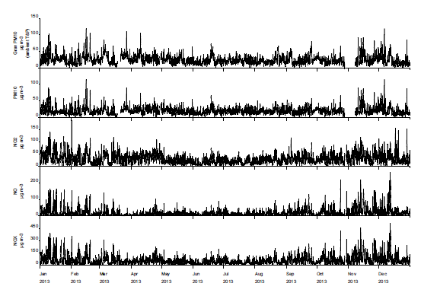
EH3: East Herts Background, Sawbridgeworth
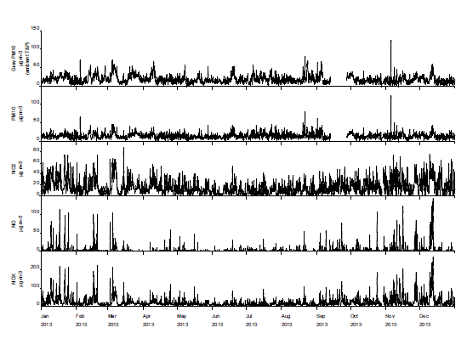
Anstey Ozone Monitor
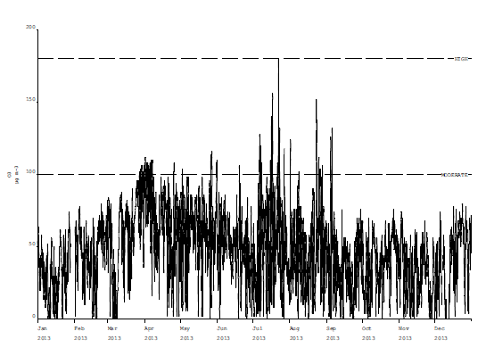

Appendix C: Detailed Breakdown of Diffusion Tube Results for 2013


